

**KARIM CITY COLLEGE, JAMSHEDPUR**

**DEPARTMENT OF COMPUTER APPLICATION**

**CERTIFICATE**

This is to certify that this investigatory Project Entitled as “ **CONSTRUCTION MANAGEMENT SYSTEM**” has being carried out by **RAHUL KUMAR CHAUDHARY of** **BCA** Part-3 under the guidance of “ **Mrs. NOORUS SABAH and Mr. ASGHAR ALI”**.

This Project work is carried out with the consultation of supervisor Noorus Sabah ma’am/ Asghar Ali sir.

It has been successfully completed as per the requirements and hope to complete in future and bring to its full operational stage.

Name: Rahul Kumar Chaudhary

Roll: BACOM16003

University Roll: 171604196524

**SIGNATURE OF EXTERNAL: _______________________________**

**SIGNATURE OF PROJECT GUIDE:**  _________________________

**SIGNATURE OF LAB-INCHARGE**: __________________________

**DATE: _______________**



**KARIM CITY COLLEGE, JAMSHEDPUR**

**DEPARTMENT OF COMPUTER APPLICATION**

**BONAFIDE LETTER**

This is to certify that **RAHUL KUMAR CHAUDHARY (171604196524)** BCA Part-3 , student of Karim City college, Jamshedpur is doing his Project in this institution from December till JUNE.

This project titled “**CONSTRUCTION MANAGEMENT SYSTEM** ” under the guidance of Mrs. Noorus Sabah mam/Asghar Ali sir. Completion letter will be given after completion of the project in June.

With regards,

Department of Computer Application,

Karim City College, Jamshedpur

Place: Signature:

Date:

**INTRODUCTION**

Construction project management is the the art of directing and coordinating human and material resources throughout the life of a project by using modern management techniques to achieve predetermined objectives of scope, cost, time, quality, and participating objectives. Wherein a construction project manager uses the model to achieve the same goal, only in a construction context.

At its most fundamental level, construction project management handles the planning, coordination, and execution of a construction project, whether it’s agricultural, residential, commercial, institutional, industrial, civil or environmental.

Construction project management typically includes complicated tasks that can shift wildly, depending on the work at hand, and it requires strong skills in communication, deep knowledge of the building process, and the ability to problem-solve. Construction project management is a complex field, requiring knowledge in many different areas like finance, law, business, and more.

Successful projects depend on every project team and every project member doing their job to a high standard, as well as flexibility and a commitment to good cross-team communication. If you love being part of a team and working with people to create something unique, project management could well be the path for you.

Project managers need to be real outside-the-box thinkers who have a dynamic approach to problem-solving.

Construction project managers 4shoulder the responsibility of keeping the project moving according to plan. The goal is to manage the project so that it finishes on schedule and within budget, while still meeting building codes, plans, and specs.

This project system includes Flat construction details, Duplex construction deatils, Customer dealing, Staff maintainance, and various types of daily and monthly reports.

Acknowledgement

It is our privilege to express our sincerest regards to our project coordinator, Mrs. Noorus Sabah/ Mr. Asghar Ali, for their valuable inputs, able guidance, encouragement, whole-hearted cooperation and constructive criticism throughout the duration of our project.

We deeply express our sincere thanks to our Head of Department Dr Prof. Anwar Sahab for encouraging and allowing us to present the project on the topic “**CONSTRUCTION MANAGEMENT SYSTEM** “ at our department premises for the partial fulfillment of the requirements leading to the award of BCA degree. We take this opportunity to thank all our lecturers who have directly or indirectly helped our project.

We pay our respects and love to our parents and all other family members and friends for their love and encouragement through out our career. Last but not the least we express our thanks to our friends for their cooperation and support.

I express my deep sense of appreciation to my wnown, without their effort and zeal , this significant project would not have been seen in the light of the day.

# PROBLEMS AND SOLUTION OF THE PROJECT

**1. Existing System:**

Our System Service is an innovative thought to manage the construction problems of

Employees of an organization. In the present System, Organization do maintain a

person for the allocating and proper functioning of transportation. The Person

appointed needs to look after the assigning of booking of Flats and Duplex.

Authorised person maintains the booking details in papers, which is a tedious task if any updations or changes need to be done.

**Problems of Existing System:**

1. It is very difficult and time consuming to maintain all the details in to the registers when the organization is very big.
2. Modifying the records is not very easy, since for a minute change the whole record would be required to re-entered. For instance, if the address of any customer changes then locating that customer and doing modification in registers is very tedious.
3. It also takes much time for doing entry and checking of records.
4. There is also possibility of mismatching of entries during entry of records.
5. To make and maintain the different reports is also very tough and tedious job.
6. Information is stored into registers, which requires large storage space.
7. Searching particular record is very tedious job, since as a time passes the condition of the registers becomes bad.
8. Every year, they have to maintain new registers.

**2. Proposed system:**

In the Previous System, Details are Stored Manually in papers, to share the details between employees was a financial drawback. Updations in the details is a tedious task.

But a new system was proposed to overcome the above drawbacks.

Functionalities and advantages of proposed system are:

1. provide information in a quick time according to the requirements

that are to be Fulfilled.

1. Easier retrieval will be possible as multiple search facilities will be

available.

1. Security of data.
2. The important process is integrated together for a proper functioning.
3. Redundancy of data is removed.
4. Inconsistency of data is removed.
5. The Paper Work would be reduced to a greater extent.

**OBJECTIVE**

The objective of this project is to implement the Construction system to the best satisfaction of the customer. The normal process which was followed until recently was to manually fill the data and then process the data which used to cause a lot of inconvenience to both the administrator and the customer as well.

Objectives of taking Event Management System are as follows:

1. This project is picked up due to the fast growing industry and the demand for the system in future.
2. The way the organizations are running requires standardization.
3. Huge scope in implementation.
4. Optimum utilisation of human, resources, materials, finance and time resources for Economical.
5. An organization for execution of the plan, organization structure will depend on types of workand time schedule.
6. Planning of each activity
7. Planning for Construction Equipments and Machinery
8. Procurement of materials
9. Planning for employee skills
10. Planning for required documents and drawings
11. This project is also picked up for the purpose of BCA project but this system can be a first step in the development field.

FEASIBILITY REPORT

**Feasibility Report**

Preliminary investigation examine project feasibility, the likelihood the system will be useful to the organization. The main objective of the feasibility study is to test the Technical, Operational and Economical feasibility for adding new modules and debugging old running system. All system is feasible if they are unlimited resources and infinite time.

There are aspects in the feasibility study portion of the preliminary investigation:

✓ Technical Feasibility

✓ Operation Feasibility

✓ Economical Feasibility

**1. Technical Feasibility**

The technical issue usually raised during the feasibility stage of the investigation includes the following:

✓ Does the necessary technology exist to do what is suggested?

✓ Do the proposed equipments have the technical capacity to hold the data required to use the new system?

✓ Will the proposed system provide adequate response to inquiries,regardless of the number or location of users?

✓ Can the system be upgraded if developed?

 ✓ Are there technical guarantees of accuracy, reliability, ease of access and

data security?

Earlier no system existed to cater to the needs of ‘Secure Infrastructure Implementation System’. The current system developed is technically feasible. It is a user interface for audit workflow at NIC-CSD. Thus it provides an easy access to the users. The database’s purpose is to create, establish and maintain a workflow among various entities in order to facilitate all concerned users in their various capacities or roles. Permission to the users would be granted based on the roles specified.

**2. Operational Feasibility**

Proposed projects are beneficial only if they can be turned out into information system. That will meet the organization’s operating requirements. Operational feasibility aspects of the project are to be taken as an important part of the project implementation.

Some of the important issues raised are to test the operational feasibility of a project includes the following: -

✓ Is there sufficient support for the management from the users?

✓ Will the system be used and work properly if it is being developed and implemented?

✓ Will there be any resistance from the user that will undermine the possible application benefits?

This system is targeted to be in accordance with the above-mentioned issues. Beforehand, the management issues and user requirements have been taken into consideration. So there is no question of resistance from the users that can undermine the possible application benefits.

**3.Economic Feasibility**

A system can be developed technically and that will be used if installed must still be a good investment for the organization. In the economical feasibility, the development cost in creating the system is evaluated against the ultimate benefit derived from the new systems. Financial benefits must equal or exceed the costs.

**HARDWARE AND SOFTWARE REQUI REMENT**

|  |  |
| --- | --- |
| RAM | 500 MB and Above |
| HARD DISK | 2 GB Hard Disk Space and Above |
| PROCESSOR | I3 Processor and Above |
| PRINTER | Laser Printer |

|  |  |
| --- | --- |
| OPERATING SYSTEM | WINDOWS OS |
| DATABASE SERVER | Oracle10g |
| FRAMEWORK SERVER | Java |
| JDK | 1.2.7 |

**Module Description**

* **Flat Entry:** It is also a master record and it is used to maintain all the status of the flat i.e. which one is booked and which is pending.
* **Duplex Entry:** It is also a master record and it is used to maintain all the status of the Duplex i.e. which one is booked and which is pending.
* **Customer Entry:** This is a master form and whenever a customer comes for booking of a particular event his/her records are kept. This may be beneficial for the organization in future.
* **staff Entry:** This module is also for master handling. Whenever staff details required they can be contacted and the customer can also be given information about them.

# Transcation Form

* **Follow-up:** A person who comes for enquiry is a potential customer and hence should not be overlooked. So follow up must be done and recorded.
* **Booking:** Construction management is a tough task and requires lots of preparation. Hence it requires time. This module is used for keeping all the booking records. This module is for transactional purpose and is very critical.
* **Enquiry:** This software is for the service industry hence lots of enquiries are done.
* **Payment:** This module is used for keeping and monitoring the payments being made. The payments are made in installments and proper monitoring should be done.
* **Booking Cancelation:** This is also of transactional level. It monitors the cancelation being done by the customer.

**Reports involved in the systems**

* **Availability Report:** This report is used to show the availability status of flats and buildings. This report is helpful for the management so that the clashes of the flats or duplex are avoided and the targets are met in time.
* **Daily Report:** This report is used to show the all the bookings done on the specific date. This report is helpful for the management when they want all deatils of specific date in a single place.
* **Monthly Report:** This report is used to show the all the payments done on the specific month. This report is helpful for the management when they want all deatils of specific month in a single place.

**Receipts:** All the payments are acknowledged and the records of the payment kept.

**Databases in the proposed system**

1.logintbl

|  |  |  |  |
| --- | --- | --- | --- |
| FIELD NAME | DATA TYPE | Size | CONSTRAINTS |
| Username | VarChar2 | 25 | Primary Key |
| Password | Varchar2 | 20 |  |

2.flattbl

|  |  |  |  |
| --- | --- | --- | --- |
| FIELD NAME | DATA TYPE | Size | CONSTRAINTS |
| flat_no | VarChar2 | 15 | Primary key |
| flat_floor | VarChar2 | 20 |  |
| flat_building | VarChar2 | 25 |  |
| flat_builtup | Number | 30 |  |
| flat_maintain | Number | 30 |  |
| flat_price | Number | 15 |  |
| flat_available | VarChar2 | 20 |  |

3.duplextbl

|  |  |  |  |
| --- | --- | --- | --- |
| FIELD NAME | DATA TYPE | Size | CONSTRAINTS |
| duplex_no | VarChar2 | 20 | Primary key |
| duplex_name | VarChar2 | 30 |  |
| duplex_builtup | Number | 20 |  |
| duplex_maintain | Number | 20 |  |
| duplex_price | Number | 50 |  |
| duplex_status | VarChar2 | 20 |  |

|  |  |  |  |
| --- | --- | --- | --- |
| FIELD NAME | DATA TYPE | Size | CONSTRAINTS |
| customer_ID | Primary Key | 20 | Primary key |
| customer_name | VarChar2 | 30 |  |
| DOB | VarChar2 | 10 |  |
| aadhar_no | Number |  |  |
| contact_no | Number |  |  |
| gender | VarChar2 | 20 |  |
| address | VarChar2 | 50 |  |
| date | VarChar2 | 20 |  |

4.customertbl

5.stafftbl

|  |  |  |  |
| --- | --- | --- | --- |
| FIELD NAME | DATA TYPE | Size | CONSTRAINTS |
| staff_ID | VarChar2 | 10 | Primary Key |
| staff_name | VarChar2 | 30 |  |
| DOB | VarChar2 | 15 |  |
| aadhar_no | Number |  |  |
| Address | VarChar2 | 50 |  |
| Designation | VarChar2 | 30 |  |
| Experience | VarChar2 | 70 |  |
| dated | VarChar2 | 20 |  |

6.FollowUptbl

|  |  |  |  |
| --- | --- | --- | --- |
| FIELD NAME | DATA TYPE | Size | CONSTRAINTS |
| followup_ID | VarChar2 | 20 | Primary key |
| enquiry_ID | VarChar2 | 20 | Foreign key |
| customer_name | VarChar2 | 30 |  |
| gender | VarChar2 | 10 |  |
| description | VarChar2 | 40 |  |
| enquiring_for | VarChar2 | 20 |  |
| status | VarChar2 | 25 |  |
| contact_no | Number |  |  |
| date | VarChar2 | 10 |  |

7.bookingtbl

|  |  |  |  |
| --- | --- | --- | --- |
| FIELD NAME | DATA TYPE | Size | CONSTRAINTS |
| booking_ID | VarChar2 | 20 | Primary key |
| date_of_booking | VarChar2 | 20 |  |
| booking_type | VarChar2 | 20 |  |
| flat_no | VarChar2 | 20 |  |
| duplex_no | VarChar2 | 20 |  |
| builtup | Number |  |  |
| maintainance | Number |  |  |
| price | Number |  |  |
| customer_ID | VarChar2 | 20 | Foreign key |
| customer_name | VarChar2 | 30 |  |
| DOB | VarChar2 | 20 |  |
| aadhar_no | Number |  |  |
| contact_no | Number |  |  |
| gender | VarChar2 | 10 |  |
| address | VarChar2 | 30 |  |

8.Enquirytbl

|  |  |  |  |
| --- | --- | --- | --- |
| FIELD NAME | DATA TYPE | Size | CONSTRAINTS |
| enquiry_ID | VarChar2 | 20 | Primary key |
| customer_name | VarChar2 | 20 |  |
| DOB | VarChar2 | 15 |  |
| aadhar_no | Number |  |  |
| contact_no | Number |  |  |
| gender | VarChar2 | 10 |  |
| address | VarChar2 | 50 |  |
| date | VarChar2 | 10 |  |
| enquiring_for | VarChar2 | 20 |  |
| status | VarChar2 | 20 |  |
| remarks | VarChar2 | 30 |  |

9.paymenttbl

|  |  |  |  |
| --- | --- | --- | --- |
| FIELD NAME | DATA TYPE | Size | CONSTRAINTS |
| payment_ID | VarChar2 | 10 | Primary key |
| date_of_payment | VarChar2 | 10 |  |
| payment_type | VarChar2 | 20 |  |
| booking_ID | VarChar2 | 10 | Foreign key |
| booking_type | VarChar2 | 20 |  |
| payment_mode | VarChar2 | 10 |  |
| amount | Number | 20 |  |
| cheque_no | Number |  |  |
| account_no | Number |  |  |
| bank_name | Number |  |  |
| customer_ID | VarChar2 | 10 | Foreign key |
| customer_name | VarChar2 | 20 |  |
| total_amt | Number |  |  |
| amt_paid | Number |  |  |
| amt_due | Number |  |  |

10.canceltbl

|  |  |  |  |
| --- | --- | --- | --- |
| FIELD NAME | DATA TYPE | Size | CONSTRAINTS |
| cancel_ID | VarChar2 | 10 | Primary key |
| booking_ID | VarChar2 | 10 | Foreign key |
| date_of_cancel | VarChar2 | 10 |  |
| reason | VarChar2 | 40 |  |
| customer_ID | VarChar2 | 10 |  |
| amount_paid | Number |  |  |
| amount_deducted | Number |  |  |
| amount_refunded | Number |  |  |

1.CONTEXT DIaGRAM/0-LEVEL DFD

STAFF

**CONSTRUCTION MANAGEMENT SYSTEM**

DUPLEX_INFO

STAFF_DETAILS

STAFF_INFO

CUST_INFO

CUST_DETAILS

CUSTOMER

FLAT_INFO

DUPLEX

FLAT

TESTING PROCEDURE AND SYSTEM IMPLEMENTATION PHASES

System testing is an important but critical part of system. Module testing involves the process of testing the logical units of program individually and integrating the individual modules, to test the overall system. The objective of module testing is to determine whether the module meets its specifications.

In order to perform module testing two things are to be considered: the design of test cases and the coordination of the multiple modules. Test cases may be constructed from specification or by analyzing the module code. The testing strategies corresponding to tests two approaches are called as black box and white box testing. In black box testing the internal structure and behavior of the program is not considered. In white box testing the structure of the program is examined and test data are derived from the program’s logic. In non-incremental approach testing modules independently and then combining them to the program without further testing test a program. In the incremental approach a module is tested in combinations with the set of previously tested modules.

The testing plans areas that are to be tested.

1) Testing for data entry error: -

Incorrect data entry, leads to incorrect results. Sometimes it may create run time errors. So data should be checked for validity.

2) Testing for basic principles: -

If all processing is in order but display of the screens is disorderly then that has to be rectified and such screen can confuse the user.

User will be left wondering on the next actions to be taken. In some of the cases operator/user has the habit of certain key for particular option. In such cases user requirements are taken into consideration.

3) Testing for suitable error messages: -

If the error messages are not suitable phases or incorrect then there can be log off problems to the user who is non-professional won’t be able to figure out what exactly the error is.

4) Testing for suitable response time: -

In some cases, the results of a particular query may take out a lot of system resources and also a longer time to process. In such cases program logic has to be rewritten. In some cases changes have been made in table.

One major factor, which has influenced the functionality of the system, is the valid data. As and when the master files were completed, the user added valid data and thus the expected results could also be verified. During testing I used incremental approach, black box testing and program instrumentation.

These processes continue till the user is fully satisfied. The data are again tested and the reports are compared with the original ones that the system should produce. The testing is done when the original data for guarantee of the outputs before it is implemented.

**FORM LAYOUT AND DESIGN**

**1.SPLASH FORM**

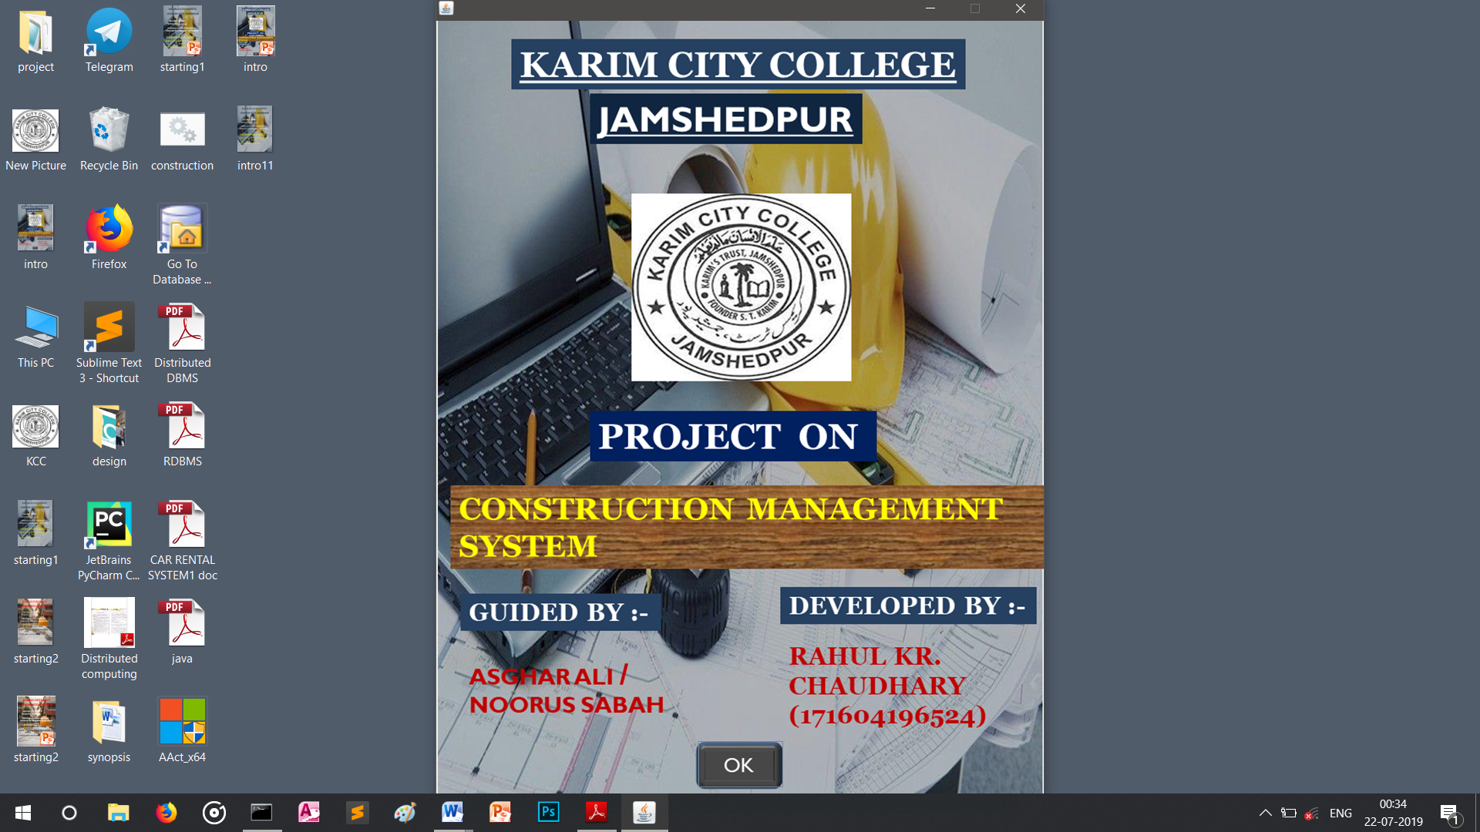

import java.awt.*;

import java.awt.event.*;

import java.applet.*;

import java.io.*;

import javax.swing.*;

import java.sql.*;

public class intro extends JFrame implements ActionListener

{

JButton btnOk=new JButton("");

JLabel limg=new JLabel("C:/Users/Rahul/OneDrive/Desktop/intro.png"));

public intro()

{

setSize(794,1040);

add(btnOk);

btnOk.setBounds(340,935,110,60);

btnOk.setContentAreaFilled(false);

btnOk.addActionListener(this);

add(limg);

}

public void actionPerformed(ActionEvent e)

{

if(e.getSource()==btnOk)

{

login obj=new login();

}

}

public static void main(String args[])throws IOException

{

intro obj=new intro();

}

}

**2.LOGIN FORM**

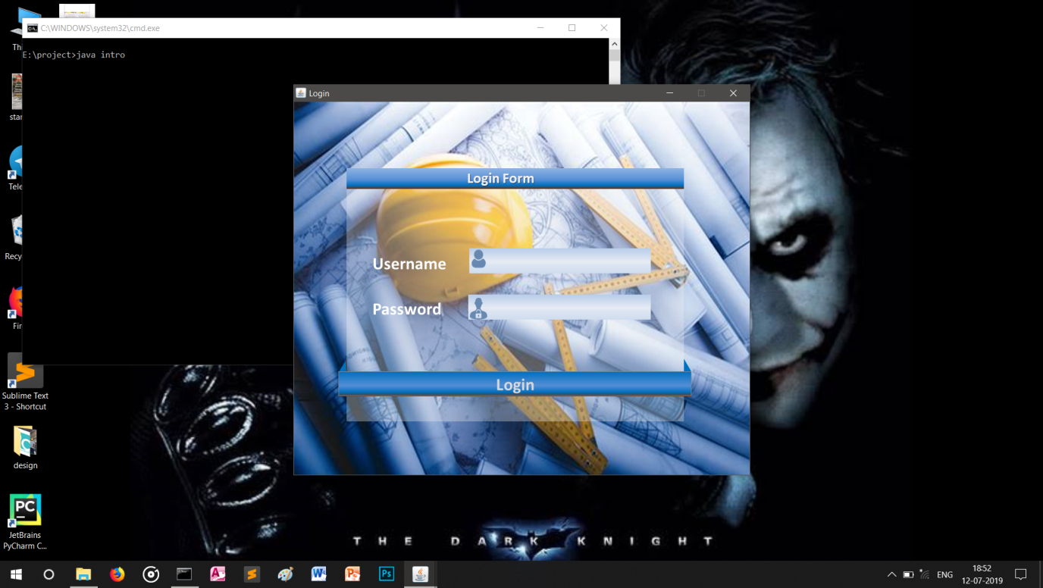

import java.awt.*;

import java.applet.*;

import java.io.*;

import java.sql.*;

public class login extends JFrame implements ActionListener

{

int ctr=0;

JTextField txtUsername=new JTextField();

JPasswordField txtPassword=new JPasswordField();

JButton btnOk=new JButton("");

JLabel limg=new JLabel(new Image ("E:/project/design/login1.png"));

public login()

{

txtUsername.setBounds(358,269,296,44);

txtPassword.setBounds(358,355,296,44);

btnOk.setBounds(82,495,650,45);

add(txtUsername);

add(txtPassword);

add(btnOk);

btnOk.addActionListener(this);

}

public void actionPerformed(ActionEvent e)

{

if(e.getSource()==btnOk)

{

try

{

Connection con=Drier.getConnection("jdbc:odbc:constructdsn");

Statement st=con.createStatement();

String str="select * from logintbl where username='"

+txtUsername.getText()+"' and password='"+spass+"'";

if(res.next())

{

JOptionPane.showMessage(null,"Login Sucessfull");

main obj=new main();

}

else

{

JOptionPane.showMessage(null,"Login Unsucessfull");

{

JOptionPane.showMessage (null,"Sorry!!! ");

}

}

catch(Exception ee)

{

System.out.print(ee);

}

public static void main(String args[])throws IOException

{

login obj=new login();

}

}

**3. MASTER FORM**

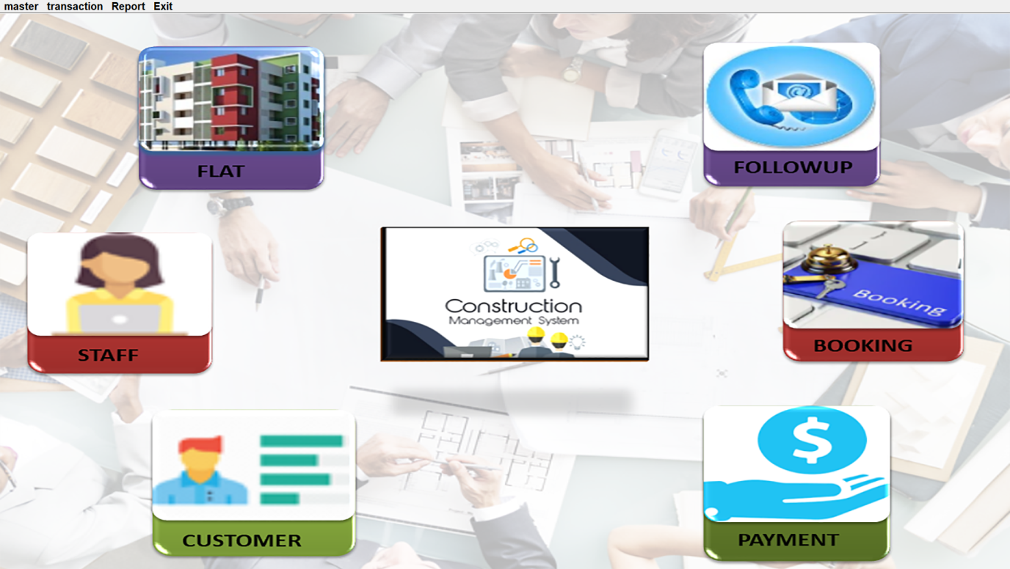

import java.io.*;

import java.awt.*;

import javax.swing.*;

import java.applet.*;

public class main extends JFrame implements ActionListener

{

MenuBar mb=new MenuBar();

Menu mnmas=new Menu("Master");

Menu mntrans=new Menu("Transaction");

Menu mnreport=new Menu("Report");

Menu mnexit=new Menu("Exit");

MenuItem flt=new MenuItem("Flat");

MenuItem dplx=new MenuItem("Duplex");

MenuItem stf=new MenuItem("Staff");

MenuItem cus=new MenuItem("Customer");

MenuItem enq=new MenuItem("Enquiry");

MenuItem flwup=new MenuItem("Follow Up");

MenuItem book=new MenuItem("Booking");

MenuItem can=new MenuItem("Cancel");

MenuItem pay=new MenuItem("Payment");

MenuItem rdate=new MenuItem("Daily Status");

MenuItem ravail=new MenuItem("Availability Status");

MenuItem rcoll=new MenuItem("Monthly Status");

MenuItem ext=new MenuItem("Exit");

public main()

{

mb.add(mnmas);

mb.add(mntrans);

mb.add(mnreport);

mb.add(mnexit);

mnmas.add(flt);

mnmas.add(dplx);

mnmas.add(stf);

mas.add(cus);

mntrans.add(enq);

mntrans.add(flwup);

mntrans.add(book);

mntrans.add(can);

mntrans.add(pay);

mnreport.add(rdate);

mnreport.add(ravail);

mnreport.add(rcoll);

mnexit.add(ext);

flt.addActionListener(this);

dplx.addActionListener(this);

stf.addActionListener(this);

cus.addActionListener(this);

enq.addActionListener(this);

flwup.addActionListener(this);

book.addActionListener(this);

can.addActionListener(this);

pay.addActionListener(this);

rdate.addActionListener(this);

ravail.addActionListener(this);

rcoll.addActionListener(this);

ext.addActionListener(this);

add(limg);

}

public void actionPerformed(ActionEvent e)

{

if(e.getSource()==flt)

{

flat obj=new flat();

}

if(e.getSource()==dplx)

{

duplex obj=new duplex();

}

if(e.getSource()==stf)

{

staff obj=new staff();

}

if(e.getSource()==cus)

{

customer obj=new customer();

}

if(e.getSource()==enq)

{

enquiry obj=new enquiry();

}

if(e.getSource()==flwup)

{

followup obj=new followup();

}

if(e.getSource()==book)

{

booking obj=new booking();

}

if(e.getSource()==can)

{

cancel obj=new cancel();

}

if(e.getSource()==pay)

{

payment obj=new payment();

}

if(e.getSource()==rdate)

{

dailyreport obj=new dailyreport();

}

if(e.getSource()==ravail)

{

availablereport obj=new availablereport();

}

if(e.getSource()==rcoll)

{

monthlyreport obj=new monthlyreport();

}

if(e.getSource()==ext)

{

this.dispose();

}

}

public static void main(String args[])throws IOException

{

main obj=new main();

}

}

4.FLAT FORM

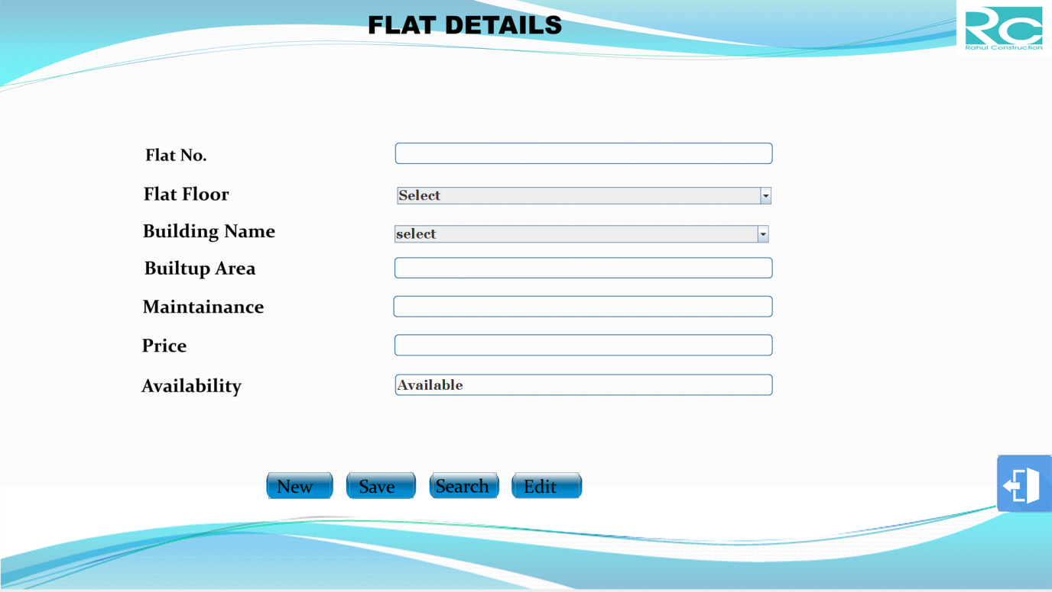

import java.awt.*;

import java.applet.*;

import java.io.*;

import java.sql.*;

public class flat extends JFrame implements ActionListener,FocusListener

{

JTextField txtFlatNo=new JTextField();

JTextField txtBuiltUpArea=new JTextField();

JTextField txtMaintainance=new JTextField();

JTextField txtPrice=new JTextField();

JTextField txtAvailable=new JTextField("Available");

JButton btnNew=new JButton("");

JButton btnSave=new JButton("");

JButton btnSearch=new JButton("");

JButton btnEdit=new JButton("");

JButton btnCancel=new JButton("");

String floor[]={"Select","0","1","2","3","4","5"};

String bname[]={"select","Ruby","Emerald","Sapphire","Diamond"};

JComboBox cmbFlatFloor=new JComboBox(floor);

JComboBox cmbBuilding=new JComboBox(bname);

public flat()

{

txtAvailable.setEditable(false);

txtFlatNo.setFont(new Font("Georgia",Font.BOLD,25));

txtBuiltUpArea.setFont(new Font("Georgia",Font.BOLD,25));

txtMaintainance.setFont(new Font("Georgia",Font.BOLD,25));

txtPrice.setFont(new Font("Georgia",Font.BOLD,25));

txtAvailable.setFont(new Font("Georgia",Font.BOLD,25));

btnNew.setFont(new Font("Georgia",Font.BOLD,30));

btnSave.setFont(new Font("Georgia",Font.BOLD,30));

btnSearch.setFont(new Font("Georgia",Font.BOLD,30));

btnEdit.setFont(new Font("Georgia",Font.BOLD,30));

btnCancel.setFont(new Font("Georgia",Font.BOLD,30));

cmbFlatFloor.setFont(new Font("Georgia",Font.BOLD,25));

cmbBuilding.setFont(new Font("Georgia",Font.BOLD,25));

txtFlatNo.setBounds(1015,498,683,34);

txtBuiltUpArea.setBounds(1015,708,683,34);

txtMaintainance.setBounds(1014,778,684,34);

txtPrice.setBounds(1015,848,683,34);

txtAvailable.setBounds(1015,921,683,34);

cmbFlatFloor.setBounds(1015,576,683,32);

cmbBuilding.setBounds(1010,646,683,32);

btnNew.setBounds(780,1097,113,48);

btnSave.setBounds(928,1097,117,47);

btnSearch.setBounds(1080,1097,117,47);

btnEdit.setBounds(1230,1097,117,47);

btnCancel.setBounds(2112,1065,110,103);

add(txtFlatNo);

add(txtBuiltUpArea);

add(txtMaintainance);

add(txtPrice);

add(txtAvailable);

add(btnNew);

add(btnSave);

add(btnSearch);

add(btnEdit);

add(btnCancel);

add(cmbFlatFloor);

add(cmbBuilding);

add(limg);

limg.setBounds(0,20,this.getWidth(),this.getHeight());

btnNew.addActionListener(this);

btnSave.addActionListener(this);

btnSearch.addActionListener(this);

btnEdit.addActionListener(this);

btnCancel.addActionListener(this);

txtBuiltUpArea.addFocusListener(this);

}

public void focusGained(FocusEvent fe)

{

if(fe.getSource()==txtBuiltUpArea && tflag==0)

{

try

{

int ctr=1;

Connection con=DriverMager.getConnection("jdbc:odbc:constructdsn");

Statement st=con.createStatement();

String str="select * from flattbl";

while(res.next())

{

if(res.getString(1).startsWith(""+cmbBuilding.getSelectedItem()))

ctr++;

}

txtFlatNo.setText(""+cmbBuilding.getSelectedItem

()+"/"+(""+cmbFlatFloor.getSelectedItem())+"/"+ctr);

}

catch(Exception e)

{

System.out.println(e);

}

public void actionPerformed(ActionEvent e)

{

if(e.getSource()==btnNew)

{

txtFlatNo.setText("");

txtBuiltUpArea.setText("");

txtMaintainance.setText("");

txtPrice.setText("");

txtAvailable.setText("Available");

cmbFlatFloor.setSelectedIndex(0);

cmbBuilding.setSelectedIndex(0);

}

if(e.getSource()==btnSave)

{

try

{

Connection con=DriverMger.getConnection("jdbc:odbc:constructdsn");

String str="insert into flattbl(flat_no,flat_floor,flat_building,

flat_builtup,flat_maintain,flat_price,flat_status)values(?,?,?,?,?,?,?)";

PreparedStatement ps=con.prepareStatement(str);

ps.setString(1,(txtFlatNo.getText()));

ps.setString(2,(""+cmbFlatFloor.getSelectedItem()));

ps.setString(3,(""+cmbBuilding.getSelectedItem()));

ps.setString(4,(txtBuiltUpArea.getText()));

ps.setString(5,(txtMaintainance.getText()));

ps.setString(6,(txtPrice.getText()));

ps.setString(7,(txtAvailable.getText()));

ps.executeUpdate();

JOptionPane.showMessage (null,"Record saved");

}

catch(Exception ee)

{

System.out.println(ee);

}

}

if(e.getSource()==btnSearch)

{

try

{

Connection con=DriverManger.getConnection("jdbc:odbc:constructdsn");

Statement st=con.createStatement();

String stt=JOptionPane.showInput(null,"Enter flat no");

String str="select * from flattbl where flat_no='"+stt+"'";

while(res.next())

{

txtFlatNo.setText(res.getString(1));

txtMaintainance.setText(res.getString(5));

txtPrice.setText(res.getString(6));

txtAvailable.setText(res.getString(7));

cmbFlatFloor.setSelectedItem(res.getString(2));

cmbBuilding.setSelectedItem(res.getString(3));

}

catch(Exception ee)

{

JOptionPane.showMessage(null,ee);

}

if(e.getSource()==btnEdit)

{

try

{

Connection con=Driver.getConnection("jdbc:odbc:constructdsn");

Statement st=con.createStatement();

String tt=JOptionPane.showInputDialog(null,"Enter flat no");

String str="update flatbl set flat='"+cmbFlatFloor.getSelectedItem

()+"',flat_Building='"+cmbBuilding.getSelectedItem()+"

',flat_builtup='"+txtBuiltUpArea.getText+"',flat_price

='"+txtPrice.getText()+"',flat_status='"+txtAvailable.getText()

st.executeUpdate(str);

JOptionPane.showMessage(null,"RECORD UPDATED");

}

catch(Exception eee)

{

JOptionPane.showMessage(null,eee);

}

}

if(e.getSource()==btnCancel)

{

this.dispose();

}

}

public static void main(String args[])throws IndexOutOfBoundsException

{

flat obj=new flat();

}

}

**5.DUPLEX FORM**

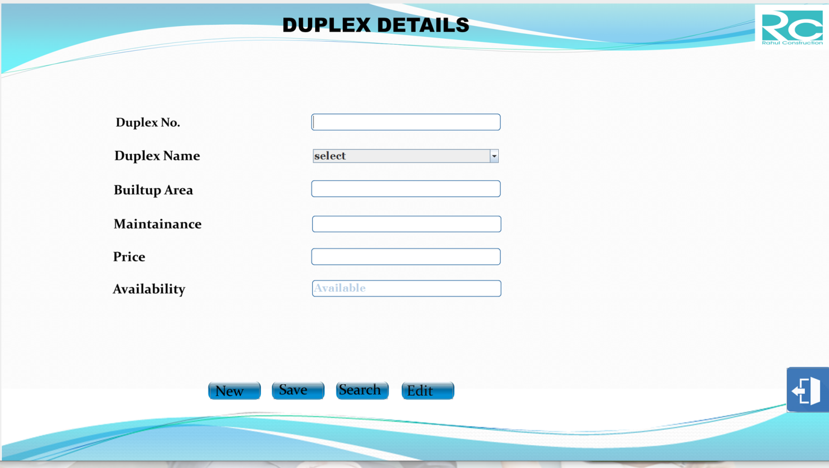

import java.awt.*;

import java.applet.*;

import java.io.*;

import java.sql.*;

public class duplex extends JFrame implements ActionListener,ItemListener

{

JTextField txtDuplexNo=new JTextField();

JTextField txtBuiltUpArea=new JTextField();

JTextField txtMaintainance=new JTextField();

JTextField txtPrice=new JTextField();

String bname[]={"select","Mannat","Jannat","Janak","Jalsa"};

JComboBox cmbDuplexName=new JComboBox(bname);

public duplex()

{

txtDuplexNo.setFont(new Font("Georgia",Font.BOLD,25));

txtBuiltUpArea.setFont(new Font("Georgia",Font.BOLD,25));

txtMaintainance.setFont(new Font("Georgia",Font.BOLD,25));

btnSave.setFont(new Font("Georgia",Font.BOLD,30));

btnSearch.setFont(new Font("Georgia",Font.BOLD,30));

btnEdit.setFont(new Font("Georgia",Font.BOLD,30));

btnCancel.setFont(new Font("Georgia",Font.BOLD,30));

cmbDuplexName.setFont(new Font("Georgia",Font.BOLD,25));

txtDuplexNo.setBounds(734,270,430,32);

txtBuiltUpArea.setBounds(734,424,430,32);

txtMaintainance.setBounds(735,506,430,32);

btnNew.setBounds(495,890,114,35);

btnSave.setBounds(642,890,114,35);

btnSearch.setBounds(792,890,114,35);

btnEdit.setBounds(943,890,114,35);

btnCancel.setBounds(1830,853,110,103);

add(txtDuplexNo);

add(txtBuiltUpArea);

add(btnSave);

add(btnSearch);

add(btnEdit);

add(btnCancel);

add(cmbDuplexName);

btnNew.addActionListener(this);

btnSave.addActionListener(this);

btnSearch.addActionListener(this);

btnEdit.addActionListener(this);

btnCancel.addActionListener(this);

}

public void actionPerformed(ActionEvent e)

{

if(e.getSource()==btnNew)

{

txtDuplexNo.setText("");

txtBuiltUpArea.setText("");

txtMaintainance.setText("");

txtPrice.setText("");

txtAvailable.setText("Available");

}

if(e.getSource()==btnSave)

{

try

{

String str="insert into duplextbl(duplex_no,duplex_name,

duplex_builtup,duplex_maintain,duplex_status)values(?,?,?,?,?)";

PreparedStatement ps=con.prepareStatement(str);

ps.setString(1,(txtDuplexNo.getText()));

ps.setString(2,(""+cmbDuplexName.getSelectedItem()));

ps.setString(3,(txtBuiltUpArea.getText()));

ps.setString(4,(txtMaintainance.getText()));

ps.setString(5,(txtPrice.getText()));

ps.setString(6,(txtAvailable.getText()));

}

catch(Exception ee)

{

System.out.println(ee);

}

if(e.getSource()==btnSearch)

{

try

{

Statement st=con.createStatement();

String stt=JOptionPane.showInput (null,"Enter Duplex No");

String str="select * from duplextbl where duplex_no='"+stt+"'";

while(res.next())

{

cmbDuplexName.setSelectedItem(res.getString(2));

txtPrice.setText(res.getString(5));

txtAvailable.setText(res.getString(6));

}

}

catch(Exception ce)

{

JOptionPane.showMessage(null,ce);

}

if(e.getSource()==btnEdit)

{

try

{

Connection con=DriverManager.getConnection("jdbc:odbc:constructdsn");

Statement st=con.createStatement();

String str="update duplextbl set duplex_name='"+cmbDuplexName

.getSelectedItem()+"',duplex_builtup='"+txtBuiltUpArea.getText()+"',

duplex_maintain='"+txtMaintainance.getText()+"',duplex_price='"+

txtPrice.getText()+"',duplex_status='"+txtAvailable.getText()+"' where

duplex_no='"+txtDuplexNo.getText()+"'";

}

if(e.getSource()==btnCancel)

{

this.dispose();

}

public static void main(String args[])throws IOException

{

duplex obj=new duplex();

}

}

**6.STAFF FORM**

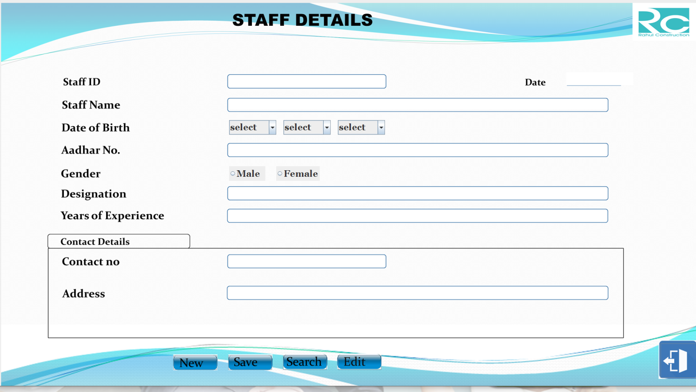

import java.awt.*;

import java.applet.*;

import java.io.*;

import java.sql.*;

import java.util.*;

public class staff extends JFrame implements ActionListener

{

JTextField txtStaffID=new JTextField();

JTextField txtStaffName=new JTextField();

JTextField txtAadharNo=new JTextField();

JTextField txtContactNo=new JTextField();

JTextField txtAddress=new JTextField();

JTextField txtDesignation=new JTextField();

JTextField txtExperience=new JTextField();

JTextField txtdate=new JTextField();

JButton btnNew=new JButton("");

JButton btnSave=new JButton("");

JButton btnSearch=new JButton("");

JButton btnEdit=new JButton("");

JButton btnCancel=new JButton("");

String sdate[]={"select","1","2","3","4","5","6","7","8","9","10","11","12","13","14

","15","16","17","18","19","20","21","22","23”,”25","26","27","28","29","30","31"};

String smonth[]={"select","Jan","Feb","Mar","Apr","May","Jun

","Jul","Aug","Sep","Oct","Nov","Dec"};

String syear[]={"select","1990","1991","1992","1993","1994","1995","1996

","1997","1998","1999","2000","2001","2002","2003","2004","2005","2006

","2007","2008","2012","2013","2014","2015","2016","2017","2018",”2019”};

JComboBox cmbDOB0=new JComboBox(sdate);

JComboBox cmbDOB1=new JComboBox(smonth);

JComboBox cmbDOB2=new JComboBox(syear);

JRadioButton rbmale=new JRadioButton("Male");

JRadioButton rbfemale=new JRadioButton("Female");

ButtonGroup bg=new ButtonGroup();

String gen="";

public staff()

{

txtStaffID.setFont(new Font("Georgia",Font.BOLD,25));

txtStaffName.setFont(new Font("Georgia",Font.BOLD,25));

txtAadharNo.setFont(new Font("Georgia",Font.BOLD,25));

txtContactNo.setFont(new Font("Georgia",Font.BOLD,25));

btnNew.setFont(new Font("Georgia",Font.BOLD,30));

btnSave.setFont(new Font("Georgia",Font.BOLD,30));

btnSearch.setFont(new Font("Georgia",Font.BOLD,30));

btnEdit.setFont(new Font("Georgia",Font.BOLD,30));

btnCancel.setFont(new Font("Georgia",Font.BOLD,30));

cmbDOB0.setFont(new Font("Georgia",Font.BOLD,25));

cmbDOB1.setFont(new Font("Georgia",Font.BOLD,25));

cmbDOB2.setFont(new Font("Georgia",Font.BOLD,25));

rbmale.setFont(new Font("Georgia",Font.BOLD,25));

rbfemale.setFont(new Font("Georgia",Font.BOLD,25));

txtStaffID.setBounds(640,213,430,32);

txtStaffName.setBounds(640,277,1043,28);

txtAadharNo.setBounds(640,402,1043,32);

txtContactNo.setBounds(640,708,430,32);

txtAddress.setBounds(640,795,1043,32);

txtDesignation.setBounds(640,521,1043,32);

txtExperience.setBounds(640,583,1043,32);

txtdate.setBounds(1570,203,150,35);

rbmale.setBounds(640,462,100,40);

rbfemale.setBounds(770,462,100,40);

btnNew.setBounds(487,983,120,40);

btnSave.setBounds(638,983,120,40);

btnSearch.setBounds(789,983,120,40);

btnEdit.setBounds(940,983,120,40);

btnCancel.setBounds(1830,950,110,95);

add(txtStaffID);

add(txtStaffName);

add(txtContactNo);

add(txtAadharNo);

add(txtAddress);

add(txtDesignation);

add(txtExperience);

add(txtdate);

add(btnNew);

add(btnSave);

add(btnSearch);

add(btnEdit);

add(btnCancel);

add(cmbDOB0);

add(cmbDOB1);

add(cmbDOB2);

add(rbmale);

add(rbfemale);

bg.add(rbmale);

bg.add(rbfemale);

btnNew.addActionListener(this);

btnSave.addActionListener(this);

btnSearch.addActionListener(this);

btnEdit.addActionListener(this);

btnCancel.addActionListener(this);

}

public void actionPerformed(ActionEvent e)

{

try

{

Connection con=DriverManger.getConnection("jdbc:odbc:constructdsn");

Statement st=con.createStatement();

String str1="select staffid from keytbl";

txtStaffID.setText("E00"+ctr);

txtStaffName.setText("");

txtAadharNo.setText("");

txtContactNo.setText("");

txtAddress.setText("");

txtDesignation.setText("");

txtExperience.setText("");

txtdate.setText(sdate);

cmbDOB0.setSelectedIndex(0);

cmbDOB1.setSelectedIndex(0);

bg.clearSelection();

}

catch( Exception e1)

{

System.out.println(e1);

}

}

if(e.getSource()==btnSave)

{

try

{

Connection con=DriverManager.getConnection("jdbc:odbc:constructdsn");

String str="insert into stafftbl(staff_ID,staff_name,DOB,aadhar_no,

gender,address,designation,experience,dated)values(?,?,?,?,?,?,?,?,?)";

PreparedStatement ps=con.prepareStatement(str);

ps.setString(1,(txtStaffID.getText()));

ps.setString(2,(txtStaffName.getText()));

ps.setString(3,sdob);

ps.setString(4,(txtAadharNo.getText()));

ps.setString(5,(txtContactNo.getText()));

ps.setString(6,gen);

ps.setString(7,(txtAddress.getText()));

ps.setString(8,(txtDesignation.getText()));

ps.setString(9,(txtExperience.getText()));

ps.setString(10,(txtdate.getText()));

ps.executeUpdate();

Statement st=con.createStatement();

st.executeUpdate(strr);

JOptionPane.showMessage(null,"Record saved");

}

catch(Exception ee)

{

System.out.println(ee);

}

}

if(e.getSource()==btnSearch)

try

{

Connection con=DriverManager.getConnection("jdbc:odbc:constructdsn");

Statement st=con.createStatement();

while(res.next())

{

txtStaffID.setText(res.getString(1));

txtStaffName.setText(res.getString(2));

txtAadharNo.setText(res.getString(4));

txtContactNo.setText(res.getString(5));

if(res.getString(6).equals("Male"))

rbmale.setSelected(true);

else

rbfemale.setSelected(true);

txtAddress.setText(res.getString(7));

txtDesignation.setText(res.getString(8));

txtExperience.setText(res.getString(9));

txtdate.setText(res.getString(10));

}

catch(Exception ce)

{

JOptionPane.showMessage(null,ce);

}

}

if(e.getSource()==btnEdit)

{

try

{

Connection =DriverManager.getConnection("jdbc:odbc:constructdsn");

Statement st=con.createStatement();

if(rbmale.isSelected())

gen="Male";

else

gen="Female";

String str1="update stafftbl set staff_name='"+txtStaffName.getText

()+"','"+cmbDOB0.getSelectedItem()+"/"+cmbDOB1.getSelectedItem

()+"/"+bDOB2.getSelectedItem()+"',aadhar_no='"+txtAadharNo.getTe

" where staff_ID='"+txtStaffID.getText()+"'";

st.executeUpdate(str1);

JOptionPane.showMessage(null,"record updated");

}

catch(Exception ee1)

{

System.out.println(ee1);

}

if(e.getSource()==btnCancel)

{

this.dispose();

}

public static void main(String args[])throws IOException

{

staff obj=new staff();

}

}

**7.CUSTOMER FORM**

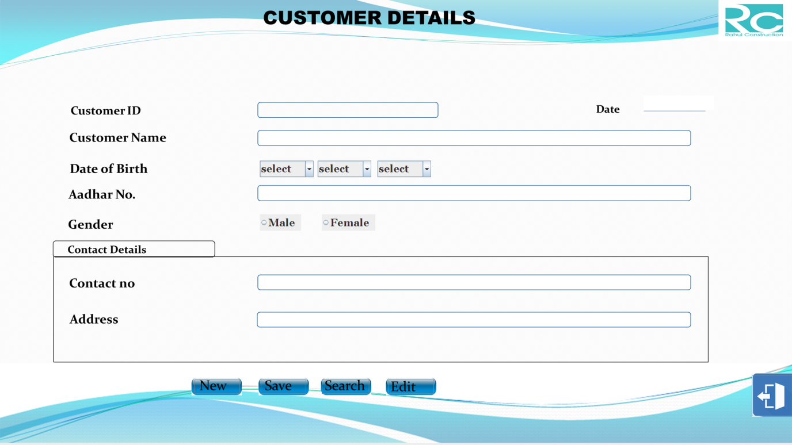

import java.awt.*;

import java.applet.*;

import java.io.*;

import java.sql.*;

import java.util.*;

public class customer extends JFrame implements ActionListener

{

JTextField txtCustomerID=new JTextField();

JTextField txtCustomerName=new JTextField();

JTextField txtAadharNo=new JTextField();

JTextField txtContactNo=new JTextField();

JTextField txtAddress=new JTextField();

JTextField txtdate=new JTextField();

JButton btnNew=new JButton("");

JButton btnSave=new JButton("");

JButton btnSearch=new JButton("");

JButton btnEdit=new JButton("");

JButton btnCancel=new JButton("");

String sdate[]={"select","1","2","3","4","5","6","8","9","10","11","12","13","14",

"16","17","18","19","20","21","22","23","24","25","26","27","28","29","30","31"};

String smonth[]={"select","Jan","Feb","Mar","Apr","May","Jun","Jul

","Aug","Sep","Oct","Nov","Dec"};

String syear[]={"select”,1992","1993","1994","1995","1996","1997","1998","1999

","2000","2001","2002","2003","2004","2005","2006","2007","2008","2009",

"2010","2011","2012","2013","2014","2015","2016","2017","2018"};

JComboBox cmbDOB0=new JComboBox(sdate);

JComboBox cmbDOB1=new JComboBox(smonth);

JComboBox cmbDOB2=new JComboBox(syear);

JRadioButton rbmale=new JRadioButton("Male");

JRadioButton rbfemale=new JRadioButton("Female");

ButtonGroup bg=new ButtonGroup();

public customer()

{

txtCustomerID.setFont(new Font("Georgia",Font.BOLD,25));

txtCustomerName.setFont(new Font("Georgia",Font.BOLD,25));

txtAadharNo.setFont(new Font("Georgia",Font.BOLD,25));

txtContactNo.setFont(new Font("Georgia",Font.BOLD,25));

txtAddress.setFont(new Font("Georgia",Font.BOLD,25));

txtdate.setFont(new Font("Georgia",Font.BOLD,30));

btnNew.setFont(new Font("Georgia",Font.BOLD,30));

btnSave.setFont(new Font("Georgia",Font.BOLD,30));

btnSearch.setFont(new Font("Georgia",Font.BOLD,30));

btnEdit.setFont(new Font("Georgia",Font.BOLD,30));

btnCancel.setFont(new Font("Georgia",Font.BOLD,30));

txtCustomerID.setBounds(920,485,430,32);

txtCustomerName.setBounds(919,555,1043,32);

txtAadharNo.setBounds(920,687,1043,33);

cmbDOB0.setBounds(920,625,130,40);

cmbDOB1.setBounds(1060,625,130,40);

cmbDOB2.setBounds(1205,625,130,40);

rbmale.setBounds(920,755,100,40);

rbfemale.setBounds(1070,755,100,40);

btnNew.setBounds(762,1156,110,35);

btnSave.setBounds(922,1156,110,35);

btnSearch.setBounds(1070,1156,115,35);

btnEdit.setBounds(1232,1156,110,35);

btnCancel.setBounds(2113,1145,100,100);

add(txtCustomerID);

add(txtCustomerName);

add(txtContactNo);

add(txtAadharNo);

add(txtAddress);

add(txtdate);

add(btnNew);

add(btnSave);

add(btnSearch);

add(btnEdit);

add(btnCancel);

add(cmbDOB0);

add(rbmale);

add(rbfemale);

bg.add(rbfemale);

btnNew.addActionListener(this);

btnSave.addActionListener(this);

btnSearch.addActionListener(this);

btnEdit.addActionListener(this);

btnCancel.addActionListener(this);

}

public void actionPerformed(ActionEvent e)

{

if(e.getSource()==btnNew)

{

txtCustomerID.setText("”);

txtCustomerName.setText("");

txtAadharNo.setText("");

txtContactNo.setText("");

txtAddress.setText("");

txtdate.setText(sdate);

cmbDOB0.setSelectedIndex(0);

cmbDOB1.setSelectedIndex(0);

cmbDOB2.setSelectedIndex(0);

}

catch( Exception e1)

{

System.out.println(e1);

}

}

if(e.getSource()==btnSave)

{

try

{

Connection con=DriverManager.getConnection("jdbc:odbc:constructdsn");

String str="insert into Customertbl(customer_ID,customer_name,DOB,

aadhar_no,contact_no,gender,address,dated)values(?,?,?,?,?,?,?,?)";

PreparedStatement ps=con.prepareStatement(str);

ps.setString(1,(txtCustomerID.getText()));

ps.setString(2,(txtCustomerName.getText()));

ps.setString(3,(txtAadhar.getText()));

ps.setString(7,(txtAddress.getText()));

ps.setString(8,(txtdate.getText()));

ps.setString(4,(txtAadharNo.getText()));

JOptionPane.showMessage (null,"Record saved");

}

}

catch(Exception ee)

{

System.out.println(ee);

}

}

if(e.getSource()==btnSearch)

{

try

{

Connection con=DriverManager.getConnection("jdbc:odbc:constructdsn");

Statement st=con.createStatement();

String str="select * from customertbl where customer_ID='"+stt+"'";

while(res.next())

{

txtCustomerID.setText(res.getString(1));

txtCustomerName.setText(res.getString(2));

txtAadharNo.setText(res.getString(4));

txtContactNo.setText(res.getString(5));

txtAddress.setText(res.getString(7));

txtdate.setText(res.getString(8));

if(res.getString(6).equals("Male"))

rbmale.setSelected(true);

else

rbfemale.setSelected(true);

String dd[]=res.getString(3).split("/");

cmbDOB0.setSelectedItem(dd[0]);

cmbDOB1.setSelectedItem(dd[1]);

cmbDOB2.setSelectedItem(dd[2]);

}

}

catch(Exception ce)

{

JOptionPane.showMessage (null,ce);

}

}

if(e.getSource()==btnEdit)

{

txtCustomerID.setEnabled(false);

txtdate.setEnabled(false);

try

{

String gen="";

Connection con=DriverManager.getConnection("jdbc:odbc:constructdsn");

Statement st=con.createStatement();

if(rbmale.isSelected())

gen="Male";

else

gen="Female";

String str1="update customertbl set customer_name='"+txtCustomerName

.getText()+"',DOB='"+cmbDOB0.getSelectedItem()+"/"+cmbDOB1.getSelec

tedItem()+"/"+cmbDOB2.getSelectedItem()+"',aadhar_no='"+txtAadharNo.

getText()+"',contact_no='"+txtContactNo.getText()+"',gender='"+gen+"',ad

dress='"+txtAddress.getText()+"' where customer_ID='"+txtCustomerID ;

st.executeUpdate(str1);

}

catch(Exception ee1)

{

System.out.println(ee1);

}

}

if(e.getSource()==btnCancel)

{

this.dispose();

}

}

public static void main(String args[])throws IOException

{

customer obj=new customer();

}

}

**8.ENQUIRY FORM**

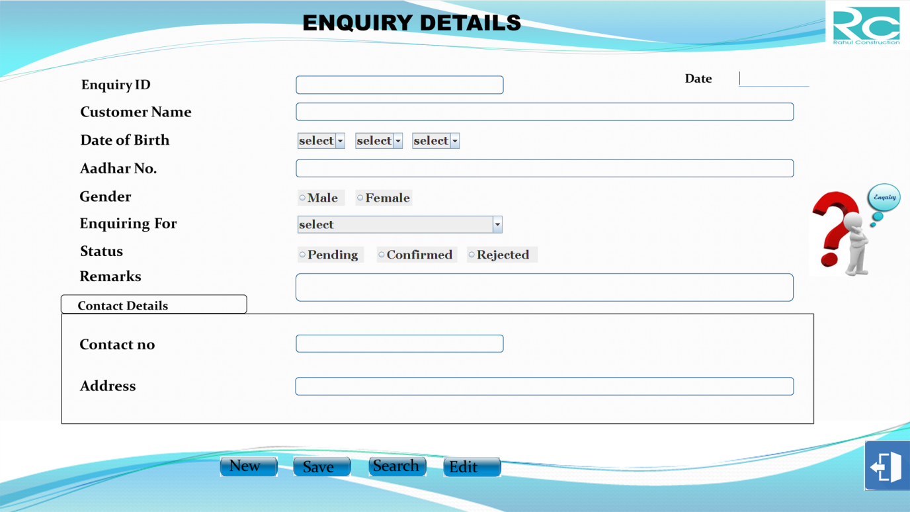

import java.awt.*;

import java.applet.*;

import java.io.*;

import java.sql.*;

import java.util.*;

public class enquiry extends JFrame implements ActionListener

{

JTextField txtEnquiryID=new JTextField();

JTextField txtCustomerName=new JTextField();

JTextField txtAadharNo=new JTextField();

JTextField txtContactNo=new JTextField();

JTextField txtAddress=new JTextField();

JTextField txtdate=new JTextField();

JTextField txtRemarks=new JTextField();

JButton btnNew=new JButton("");

JButton btnSave=new JButton("");

JButton btnSearch=new JButton("");

JButton btnEdit=new JButton("");

JButton btnCancel=new JButton("");

String sdate[]={"select","1","2","3","4","5","6","7","8","9","10","11","12","13","14

","15","16","17","18","19","20","21","22","23","25","26","27","28","30","31"};

String smonth[]={"select","Jan","Feb","Mar","Apr","May","Jun","Jul

","Aug","Sep","Oct","Nov","Dec"};

String syear[]={"select","1990","1991","1992","1993","1994","1995","1996

","1997","1998","1999","2000","2001","2002","2003","2004","2005","2006

","2007","2008","2010,"2013","2014","2015","2016","2017","2018",”2019”};

String senquiry[]={"select","Flat","Duplex"};

JComboBox cmbEnquiry=new JComboBox(senquiry);

JRadioButton rbmale=new JRadioButton("Male");

JRadioButton rbfemale=new JRadioButton("Female");

ButtonGroup bg=new ButtonGroup();

JRadioButton rbpending=new JRadioButton("Pending");

JRadioButton rbconfirmed=new JRadioButton("Confirmed");

JRadioButton rbrejected=new JRadioButton("Rejected");

ButtonGroup bgs=new ButtonGroup();

public enquiry()

{

txtEnquiryID.setBounds(628,163,432,34);

txtCustomerName.setBounds(628,219,1043,34);

txtAadharNo.setBounds(628,338,1043,34);

txtdate.setBounds(1560,150,150,35);

txtRemarks.setBounds(628,579,1043,55);

txtContactNo.setBounds(628,708,1043,34);

txtAddress.setBounds(628,798,1043,34);

cmbDOB0.setBounds(628,280,100,34);

cmbDOB1.setBounds(750,280,100,34);

cmbDOB2.setBounds(870,280,100,34);

cmbEnquiry.setBounds(628,455,432,37);

rbmale.setBounds(628,400,100,34);

rbfemale.setBounds(750,400,100,34);

rbpending.setBounds(628,520,130,34);

rbconfirmed.setBounds(785,520,150,34);

rbrejected.setBounds(965,520,130,34);

btnNew.setBounds(467,965,115,40);

btnSave.setBounds(620,965,117,40);

btnSearch.setBounds(780,965,117,40);

btnEdit.setBounds(937,965,117,40);

btnCancel.setBounds(1825,930,120,105);

add(txtEnquiryID);

add(txtCustomerName);

add(txtContactNo);

add(txtAadharNo);

add(txtAddress);

add(txtdate);

add(txtRemarks);

add(btnNew);

add(btnSave);

add(btnSearch);

add(btnEdit);

add(btnCancel);

add(rbmale);

add(rbfemale);

add(rbpending);

add(rbconfirmed);

add(rbrejected);

bg.add(rbmale);

bg.add(rbfemale);

btnNew.addActionListener(this);

btnSave.addActionListener(this);

btnSearch.addActionListener(this);

btnEdit.addActionListener(this);

btnCancel.addActionListener(this);

}

public void actionPerformed(ActionEvent e)

{

try

{

txtEnquiryID.setText("”);

txtCustomerName.setText("");

txtAadharNo.setText("");

txtContactNo.setText("");

txtAddress.setText("");

txtdate.setText(sdate);

txtRemarks.setText("");

}

catch( Exception e1)

{

System.out.println(e1);

}

}

if(e.getSource()==btnSave)

{

try

{

Connection con=Driver.getConnection("jdbc:odbc:constructdsn");

String str="insert into enquirytbl(enquiry_ID,customer_name,DOB

,aadhar_no,contact_no,gender,address,dated,enquiring_for,status,

remarks)values(?,?,?,?,?,?,?,?,?,?,?)";

ps.setString(1,(txtEnquiryID.getText()));

ps.setString(2,(txtCustomerName.getText()));

ps.setString(7,(txtAddress.getText()));

ps.setString(8,(txtdate.getText()));

ps.setString(11,(txtRemarks.getText()));

ps.setString(4,(txtAadharNo.getText()));

ps.setString(5,(txtContactNo.getText()));

ps.setString(6,gen);

ps.setString(10,stat);

ps.setString(3,sdob);

ps.setString(9,(""+cmbEnquiry.getSelectedItem()));

Statement st=con.createStatement();

st.executeUpdate(strr);

JOptionPane.showMessage(null,"Record saved");

}

}

catch(Exception ee)

{

System.out.println(ee);

}

}

if(e.getSource()==btnSearch)

{

try

{

Connection con=DriverMan.getConnection("jdbc:odbc:constructdsn");

Statement st=con.createStatement();

String stt=JOptionPane.showInput(null,"Enter Enquiry ID");

String str="select * from enquirytbl where enquiry_ID='

"+txtEnquiryID.getText()+"'";

ResultSet res=st.executeQuery(str);

while(res.next())

{

txtCustomerName.setText(res.getString(2));

txtAadharNo.setText(res.getString(4));

txtContactNo.setText(res.getString(5));

txtAddress.setText(res.getString(7));

txtdate.setText(res.getString(8));

cmbEnquiry.setSelectedItem(res.getString(9));

txtRemarks.setText(res.getString(11));

}

catch(Exception ce)

{

JOptionPane.showMessag(null,ce);

}

}

if(e.getSource()==btnEdit)

{

try

{

Connection con=Driver.getConnection("jdbc:odbc:constructdsn");

Statement st=con.createStatement();

String str1="update enquirytbl set customer_name='"+txtCustomer

Name.getText()+"',DOB='"+cmbDOB0.getSelectedItem()+"-"+cmb

DOB1.getSelectedItem()+"-"+cmbDOB2.getSelectedItem()+"',aadhar

='"+txtAadharNo.getText()+"',contact_no='"+txtContactNo.getText()

+"',Gender='"+gen+"',address='"+txtAddress.getText()+"',enquirin

='"+cmbEnquiry.getSelectedItem()+"',status='"+stat+"',remarks='"+

' where enquiry_ID='"+txtEnqu.getText()+"'";

st.executeUpdate(str1);

JOptionPane.showMessage(null,"record updated");

}

catch(Exception ee1)

{

System.out.println(ee1);

}

}

if(e.getSource()==btnCancel)

{

this.dispose();

}

}

public static void main(String args[])throws IOException

{

enquiry obj=new enquiry();

}

}

**9.FOLLOWUP FORM**

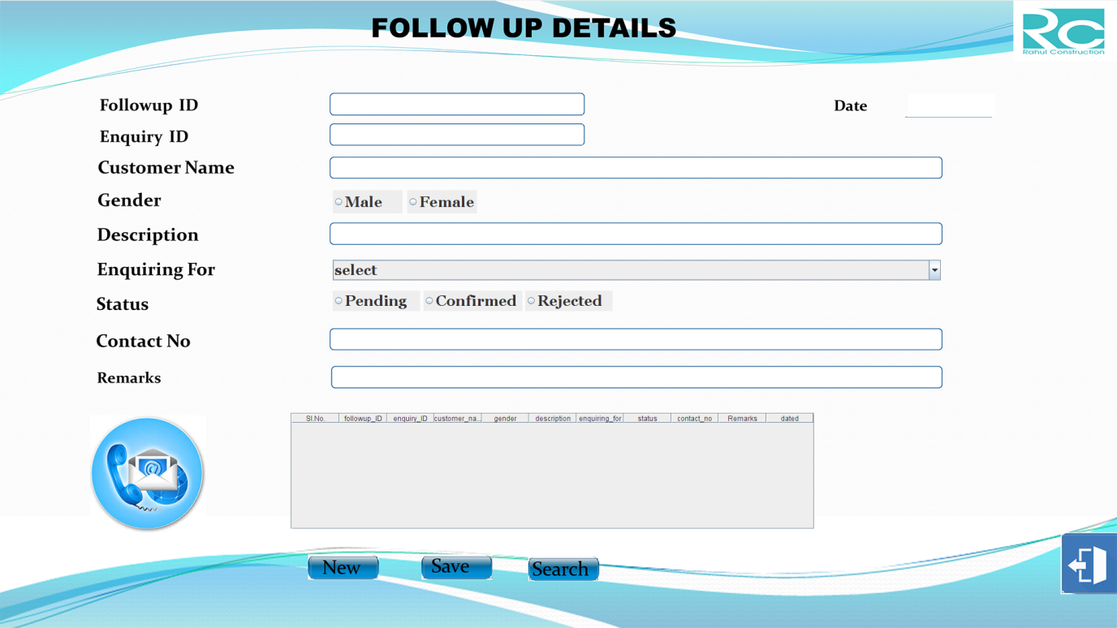

import java.awt.*;

import java.applet.*;

import java.io.*;

import java.sql.*;

import java.util.*;

import javax.swing.table.DefaultTableModel;

public class followup extends JFrame implements ActionListener,FocusListener

{

JTextField txtFollowUpID=new JTextField();

JTextField txtEnquiryID=new JTextField();

JTextField txtCustomerName=new JTextField();

JTextField txtDesc=new JTextField();

JTextField txtStatus=new JTextField();

JTextField txtContactNo=new JTextField();

JTextField txtRemarks=new JTextField();

JTextField txtdate=new JTextField();

JButton btnNew=new JButton("");

JButton btnSave=new JButton("");

JButton btnSearch=new JButton("");

JButton btnEdit=new JButton("");

JButton btnCancel=new JButton("");

String senquiry[]={"select","Flat","Duplex"};

JComboBox cmbEnquiry=new JComboBox(senquiry);

JRadioButton rbmale=new JRadioButton("Male");

JRadioButton rbfemale=new JRadioButton("Female");

ButtonGroup bg=new ButtonGroup();

JRadioButton rbpending=new JRadioButton("Pending");

JRadioButton rbconfirmed=new JRadioButton("Confirmed");

JRadioButton rbrejected=new JRadioButton("Rejected");

ButtonGroup bgs=new ButtonGroup();

public followup()

{

txtFollowUpID.setFont(new Font("Georgia",Font.BOLD,25));

txtEnquiryID.setFont(new Font("Georgia",Font.BOLD,25));

txtCustomerName.setFont(new Font("Georgia",Font.BOLD,25));

txtDesc.setFont(new Font("Georgia",Font.BOLD,25));

txtContactNo.setFont(new Font("Georgia",Font.BOLD,25));

txtRemarks.setFont(new Font("Georgia",Font.BOLD,30));

txtdate.setFont(new Font("Georgia",Font.BOLD,30));

btnNew.setFont(new Font("Georgia",Font.BOLD,30));

btnSave.setFont(new Font("Georgia",Font.BOLD,30));

btnSearch.setFont(new Font("Georgia",Font.BOLD,30));

btnEdit.setFont(new Font("Georgia",Font.BOLD,30));

btnCancel.setFont(new Font("Georgia",Font.BOLD,30));

rbmale.setFont(new Font("Georgia",Font.BOLD,25));

rbfemale.setFont(new Font("Georgia",Font.BOLD,25));

rbpending.setFont(new Font("Georgia",Font.BOLD,25));

rbconfirmed.setFont(new Font("Georgia",Font.BOLD,25));

rbrejected.setFont(new Font("Georgia",Font.BOLD,25));

txtFollowUpID.setBounds(572,162,430,35);

txtEnquiryID.setBounds(572,214,430,35);

txtCustomerName.setBounds(574,271,1040,33);

txtDesc.setBounds(572,386,1043,33);

txtContactNo.setBounds(573,567,1043,33);

txtRemarks.setBounds(573,632,1043,33);

txtdate.setBounds(1558,161,150,40);

rbmale.setBounds(572,327,100,40);

rbfemale.setBounds(700,327,100,40);

rbpending.setBounds(572,500,130,35);

rbconfirmed.setBounds(725,500,140,35);

rbrejected.setBounds(888,500,130,35);

cmbEnquiry.setBounds(572,447,1045,35);

btnNew.setBounds(466,957,115,38);

btnSave.setBounds(620,957,118,38);

btnSearch.setBounds(772,960,118,38);

btnEdit.setBounds(900,962,118,38);

btnCancel.setBounds(1825,920,120,100);

add(txtFollowUpID);

add(txtEnquiryID);

add(txtCustomerName);

add(txtDesc);

add(txtContactNo);

add(txtRemarks);

add(txtdate);

add(btnNew);

add(btnSave);

add(btnSearch);

add(btnEdit);

add(btnCancel);

add(rbmale);

add(rbfemale);

add(rbpending);

add(rbconfirmed);

add(rbrejected);

add(cmbEnquiry);

bg.add(rbmale);

bg.add(rbfemale);

btnNew.addActionListener(this);

btnSave.addActionListener(this);

btnSearch.addActionListener(this);

btnEdit.addActionListener(this);

btnCancel.addActionListener(this);

}

public void actionPerformed(ActionEvent e)

{

if(e.getSource()==btnNew)

{

try

{

Connection con=Drivr.getConnection("jdbc:odbc:constructdsn");

Statement st=con.createStatement();

String str1="select fupid from keytbl";

while(res.next())

{

txtFollowUpID.setText("”);

txtEnquiryID.setText("");

txtCustomerName.setText("");

txtDesc.setText("");

txtContactNo.setText("");

txtRemarks.setText("");

txtdate.setText(sdate);

cmbEnquiry.setSelectedIndex(0);

}

catch( Exception e1)

{

System.out.println(e1);

}

}

if(e.getSource()==btnSave)

{

try

{

Connection con=DriverManager.getConnection("jdbc:odbc:constructdsn");

String str="";

PreparedStatement ps;

Statement st1=con.createStatement();

ResultSet rs1=st1.executeQuery("Select status from enquirytbl where

enquiry_ID='"+txtEnquiryID.getText()+"' and status='Pending'");

while(rs1.next())

{

String sstr="insert into followuptbl(followup_ID,enquiry_ID,

customer_name,gender,description,enquiring_for,status,contact_no,

remarks,dated)values(?,?,?,?,?,?,?,?,?,?)";

ps=con.prepareStatement(sstr);

ps.setString(1,txtFollowUpID.getText());

ps.setString(2,txtEnquiryID.getText());

ps.setString(3,txtCustomerName.getText());

ps.setString(4,gen);

ps.setString(5,txtDesc.getText());

ps.setString(6,(""+cmbEnquiry.getSelectedItem()));

ps.setString(7,stat);

ps.setString(8,txtContactNo.getText());

ps.setString(9,txtRemarks.getText());

ps.setString(10,txtdate.getText());

ps=con.prepareStatement(sstr);

}

}

catch(Exception ee)

{

System.out.println(ee);

}

}

if(e.getSource()==btnSearch)

{

try

{

String stat="";

Connection con=Driver.getConnection("jdbc:odbc:constructdsn");

Statement st=con.createStatement();

String str="select * from followuptbl where enquiry_ID='"+stt+"'";

while(res.next())

{

txtFollowUpID.setText(res.getString(1));

txtCustomerName.setText(res.getString(3));

txtDesc.setText(res.getString(5));

txtContactNo.setText(res.getString(8));

txtRemarks.setText(res.getString(9));

if(res.getString(4).equals("Male"))

rbmale.setSelected(true);

else

rbfemale.setSelected(true);

txtdate.setText(res.getString(10));

cmbEnquiry.setSelectedItem(res.getString(6));

stat=res.getString(7);

if(stat.equals("Pending"))

rbpending.setSelected(true);

}

}

catch(Exception ce)

{

JOptionPane.showMessage(null,ce);

}

}

if(e.getSource()==btnEdit)

{

try

{

String gen="",stat="";

Connection con=Driver.getConnection("jdbc:odbc:constructdsn");

Statement st=con.createStatement();

if(rbmale.isSelected())

gen="Male";

else

gen="Female";

if(rbpending.isSelected())

stat="Pending";

.getText()+"',customer_name='"+txtCustomerName.getText()+"',

remarks='"+txtRemarks.getText()+"' where enquiry_ID='"+txt

EnquiryID.+"'and followup_ID='"+txtFollowUpID.getText()+"'";

st.executeUpdate(str1);

JOptionPane.showMessage(null,"record updated");

}

catch(Exception ee1)

{

System.out.println(ee1);

}

}

if(e.getSource()==btnCancel)

{

this.dispose();

}

}

public static void main(String args[])throws IOException

{

followup obj=new followup();

}

}

**10.BOOKING FORM**

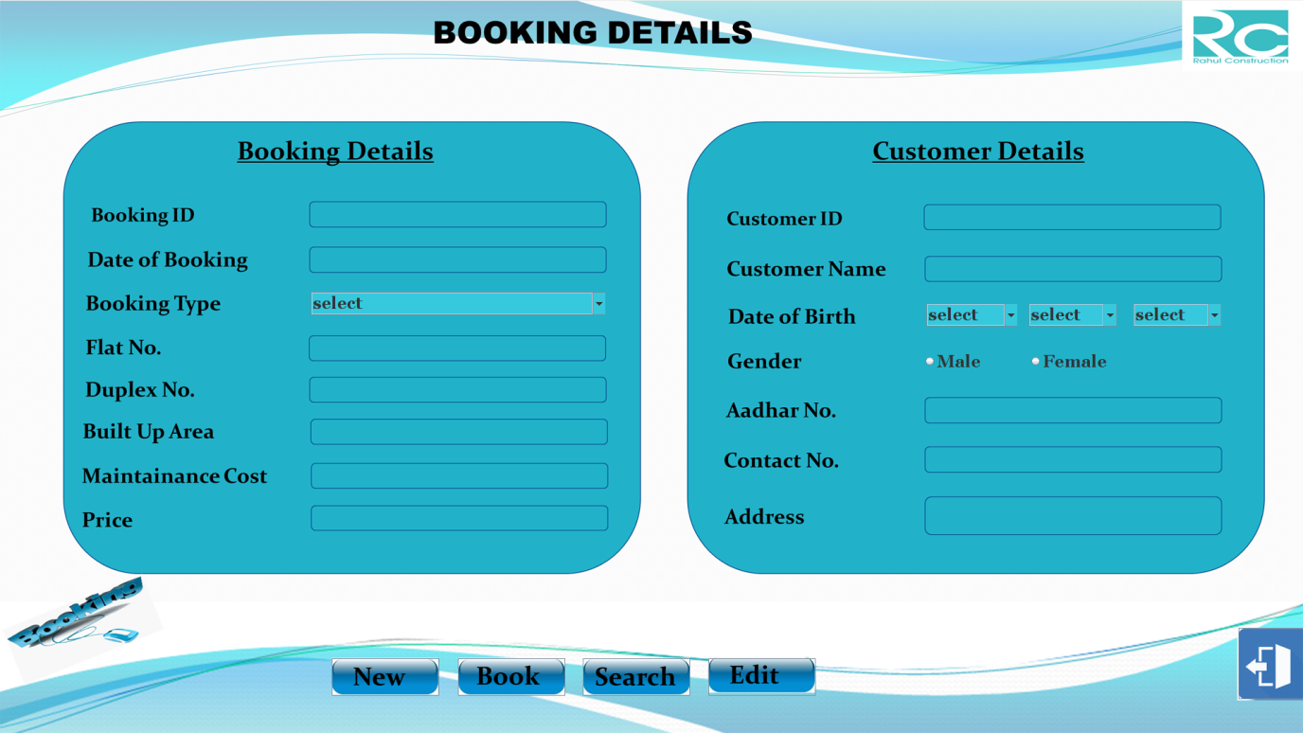

import java.awt.*;

import java.applet.*;

import java.io.*;

import java.sql.*;

import java.util.*;

public class booking extends JFrame implements ActionListener

{

JTextField txtBookingID=new JTextField("");

JTextField txtDateOfBooking=new JTextField("");

JTextField txtFlatNo=new JTextField("");

JTextField txtDuplexNo=new JTextField("");

JTextField txtBuiltUpArea=new JTextField("");

JTextField txtMaintainance=new JTextField("");

JTextField txtdate=new JTextField("");

JButton btnNew=new JButton("");

JButton btnBook=new JButton("");

JButton btnSearch=new JButton("");

JButton btnEdit=new JButton("");

JButton btnCancel=new JButton("");

String sdate[]={"select","1","2","3","4","5","6","7","8","9","10","11","12","13","

14","15","16","17","18","19","22","23","24","25","26","27","28","29","30","31"};

String smonth[]={"select","Jan","Feb","Mar","Apr","May","Jun","Jul

","Aug","Sep","Oct","Nov","Dec"};

String syear[]={"select","1990","1991","1992","1993","1994","1995","1996

","1997","1998","1999","2000","2001","2002","2003","2004","2005","2006

","2007","2011","2012","2013","2014","2015","2016","2017","2018",”2019”};

JComboBox cmbDOB0=new JComboBox(sdate);

JComboBox cmbDOB1=new JComboBox(smonth);

JComboBox cmbDOB2=new JComboBox(syear);

String btype[]={"select","Flat","Duplex"};

JComboBox cmbBookingType=new JComboBox(btype);

JRadioButton rbmale=new JRadioButton("Male");

JRadioButton rbfemale=new JRadioButton("Female");

ButtonGroup bg=new ButtonGroup();

public booking()

{

txtBookingID.setBounds(460,298,430,34);

txtDateOfBooking.setBounds(460,365,430,34);

txtFlatNo.setBounds(460,495,430,34);

txtDuplexNo.setBounds(460,557,430,34);

txtBuiltUpArea.setBounds(460,619,430,34);

txtMaintainance.setBounds(460,683,430,34);

btnNew.setBounds(489,970,158,55);

btnBook.setBounds(675,970,158,55);

btnSearch.setBounds(859,970,158,55);

btnEdit.setBounds(1044,970,158,55);

btnCancel.setBounds(1825,925,120,105);

add(txtBookingID);

add(txtDateOfBooking);

add(txtFlatNo);

add(txtDuplexNo);

add(txtBuiltUpArea);

add(btnNew);

add(btnBook);

add(btnSearch);

add(btnEdit);

add(btnCancel);

btnNew.addActionListener(this);

btnBook.addActionListener(this);

btnSearch.addActionListener(this);

btnEdit.addActionListener(this);

btnCancel.addActionListener(this);

}

public void actionPerformed(ActionEvent e)

{

if(e.getSource()==btnNew)

{

try

{

Connection con=Driver.getConnect("jdbc:odbc:constructdsn");

Statement st=con.createStatement();

res=st.executeQuery(str1);

txtBookingID.setText("”);

txtDateOfBooking.setText(sdate);

txtFlatNo.setText("");

txtDuplexNo.setText("");

txtBuiltUpArea.setText("");

}

catch( Exception e1)

{

System.out.println(e1);

}

}

if(e.getSource()==btnBook)

{

try

{

Connection con=Driver.getConnection("jdbc:odbc:constructdsn");

String sas="select * from bookingtbl where booking_ID=

'"+txtBookingID.getText()+"'" ;

Statement st3=con.createStatement();

String str="insert into bookingtbl(booking_ID,date_of_booking,

booking_type,flat_no,duplex_no,builtup,maintainance,price,custo

,DOB,aadhar,contact_no,gender)values(?,?,?,?,?,?,?,?,?,?,?,?,?,?,?)";

PreparedStatement ps=con.prepareStatement(str);

ps.setString(1,(txtBookingID.getText()));

ps.setString(2,(txtDateOfBooking.getText()));

ps.setString(3,(""+cmbBookingType.getSelectedItem()));

ps.setString(4,flatno);

ps.setString(5,dupno);

ps.setString(6,(txtBuiltUpArea.getText()));

ps.setString(7,(txtMaintainance.getText()));

ps.setString(8,(txtPrice.getText()));

ps.setString(9,(txtCustomerID.getText()));

ps.setString(10,(txtCustomerName.getText()));

ps.setString(11,sdob);

ps.setString(12,(txtAadharNo.getText()));

ps.setString(13,(txtContactNo.getText()));

ps.setString(14,gen);

ps.setString(15,(txtAddress.getText()));

}

if(e.getSource()==btnSearch)

{

try

{

Connection con=Driver.getConnect("jdbc:odbc:constructdsn");

Statement st=con.createStatement();

while(res.next())

{

txtDateOfBooking.setText(res.getString(2));

txtFlatNo.setText(res.getString(4));

txtDuplexNo.setText(res.getString(5));

txtCustomerID.setText(res.getString(9));

txtCustomerName.setText(res.getString(10));

txtAadharNo.setText(res.getString(12));

txtContactNo.setText(res.getString(13))

if(res.getString(14).equals("Male"));

rbmale.setSelected(true);

txtAddress.setText(res.getString(15));

}

catch(Exception ee)

{

JOptionPane.showMessage(null,ee);

}

}

if(e.getSource()==btnEdit)

{

try

{

Connection =Driver.getCon("jdbc:odbc:constructdsn");

Statement st=con.createStatement();

if(rbmale.isSelected())

gen="Male";

else

gen="Female";

String str="update bookingtbl set date_of_booking='"+

txtDateOfBooking.getText()+"',booking_type='"+cmbBooking

TypegetSelectedItem()+"',flat_no='"+txtFlatNo.getText()+"',

dupl_no='"+txtDuplexNo.getText()+"',builtup='"+txtBuiltUp

',aadhar_no='"+txtAadharNo.get+"',contact_no='"+txtContact

getText()+"',gen='"+gen+"' where booking_ID='"+tt+"'";

JOptionPane.showMessage(null,"RECORD UPDATED");

}

catch(Exception eee)

{

JOptionPane.showMessage(null,eee);

}

}

if(e.getSource()==btnCancel)

{

this.dispose();

}

}

public static void main(String args[])throws IOException

{

booking obj=new booking();

}

}

**11.PAYMENT FORM**

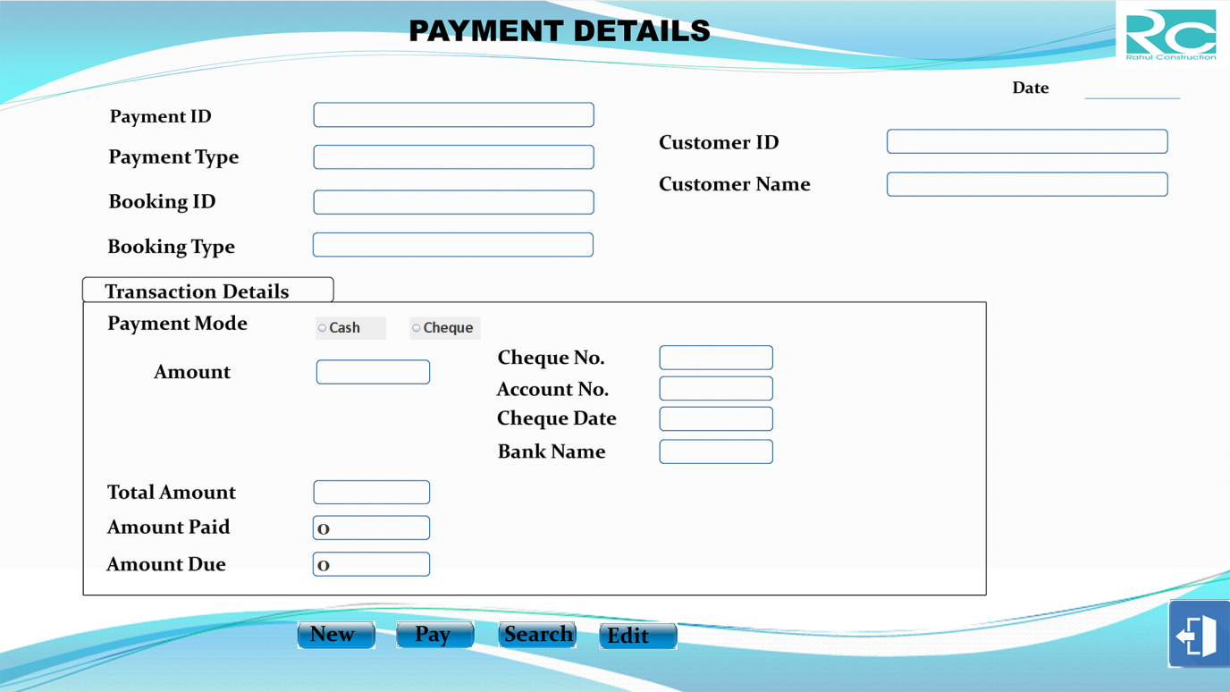

import java.awt.*;

import java.applet.*;

import java.io.*;

import java.sql.*;

import java.util.*;

public class payment extends JFrame implements ActionListener,FocusListener

{

JTextField txtPaymentID=new JTextField("");

JTextField txtDateOfPayment=new JTextField("");

JTextField txtPaymentType=new JTextField("");

JTextField txtBookingID=new JTextField("");

JTextField txtBookingType=new JTextField("");

JTextField txtCustomerID=new JTextField("");

JTextField txtCustomerName=new JTextField("");

JTextField txtAmountPaid=new JTextField("");

JTextField txtAmountDue=new JTextField("");

JTextField txtAmount=new JTextField("");

JTextField txtTotalAmount=new JTextField("");

JTextField txtChequeNo=new JTextField("");

JTextField txtAccountNo=new JTextField("");

JTextField txtChequeDate=new JTextField("");

JTextField txtBankName=new JTextField("");

JButton btnNew=new JButton("");

JButton btnPay=new JButton("");

JButton btnSearch=new JButton("");

JButton btnEdit=new JButton("");

JButton btnCancel=new JButton("");

JRadioButton rbcash=new JRadioButton("Cash");

JRadioButton rbcheque=new JRadioButton("Cheque");

ButtonGroup bg=new ButtonGroup();

public payment()

{

txtPaymentID.setBounds(493,162,432,35);

txtDateOfPayment.setBounds(1693,119,150,35);

txtPaymentType.setBounds(493,228,432,35);

txtBookingID.setBounds(493,299,431,35);

txtBookingType.setBounds(493,365,431,35);

txtCustomerID.setBounds(1387,204,432,35);

txtCustomerName.setBounds(1387,271,432,35);

txtAmount.setBounds(496,564,173,34);

txtChequeNo.setBounds(1032,541,173,35);

txtAccountNo.setBounds(1032,589,173,35);

txtChequeDate.setBounds(1032,637,173,35);

txtBankName.setBounds(1032,688,173,35);

txtTotalAmount.setBounds(495,752,173,34);

txtAmountPaid.setBounds(494,807,173,33);

txtAmountDue.setBounds(494,864,173,33);

rbcash.setBounds(493,495,110,35);

rbcheque.setBounds(640,495,110,35);

btnNew.setBounds(467,970,115,40);

btnPay.setBounds(620,970,117,40);

btnSearch.setBounds(780,970,117,40);

btnEdit.setBounds(937,973,117,40);

btnCancel.setBounds(1827,935,120,105);

add(txtPaymentID);

add(txtDateOfPayment);

add(txtPaymentType);

add(txtBookingID);

add(txtBookingType);

add(txtCustomerID);

add(txtCustomerName);

add(txtTotalAmount);

add(txtAmountPaid);

add(btnNew);

add(btnPay);

add(btnSearch);

add(btnEdit);

add(btnCancel);

btnNew.addActionListener(this);

btnPay.addActionListener(this);

btnSearch.addActionListener(this);

btnEdit.addActionListener(this);

btnCancel.addActionListener(this);

}

if(e.getSource()==btnNew)

{

try

{

txtPaymentID.setText("");

txtDateOfPayment.setText(sdate);

txtPaymentType.setText("");

txtBookingID.setText("");

txtBookingType.setText("");

txtTotalAmount.setText("");

txtAmountPaid.setText("");

txtAmountDue.setText("");

txtCustomerID.setText("");

txtCustomerName.setText("");

bg.clearSelection();

}

catch( Exception e1)

{

System.out.println(e1);

}

}

if(e.getSource()==btnPay)

{

try

{

Connection con=DriverManag.getConnection("jdbc:odbc:constructdsn");

String str="insert into paymenttbl(payment_ID,date_of_payment,

payment_type,booking_ID,booking_type,payment_mode,

amount,cheque_no,account_no,cheque_date,bank_name,customer_ID

,customer,total,amt_paid,amt_due)values(?,?,?,?,?,?,?,?,?,?,?,?,?,?)";

ps.setString(1,(txtPaymentID.getText()));

ps.setString(2,(txtDateOfPayment.getText()));

ps.setString(3,(txtPaymentType.getText()));

ps.setString(4,(txtBookingID.getText()));

ps.setString(5,(txtBookingType.getText()));

ps.setString(7,(txtAmount.getText()));

ps.setString(12,(txtCustomerID.getText()));

ps.setString(13,(txtCustomerName.getText()));

ps.setString(14,(txtTotalAmount.getText()));

ps.setString(15,(txtAmountPaid.getText()));

ps.setString(16,(txtAmountDue.getText()));

}

catch(Exception ee)

{

System.out.println(ee);

}

}

if(e.getSource()==btnSearch)

{

try

{

Connection con=Driver.getConnection("jdbc:odbc:constructdsn");

Statement st=con.createStatement();

String stt=JOptionPane.showInput(null,"Enter Payment ID");

String str="select * from paymenttbl where payment_ID='

"+txtPaymentID.getText()+"'";

while(res.next())

{

txtPaymentID.setText(stt);

txtDateOfPayment.setText(res.getString(2));

txtPaymentType.setText(res.getString(3));

txtBookingID.setText(res.getString(4));

txtBookingType.setText(res.getString(5));

if(res.getString(6).equals("Cash"))

rbcash.setSelected(true);

else

rbcheque.setSelected(true);

txtAmount.setText(res.getString(7));

txtChequeNo.setText(res.getString(8));

txtAccountNo.setText(res.getString(9));

txtChequeDate.setText(res.getString(10));

txtBankName.setText(res.getString(11));

txtCustomerID.setText(res.getString(12));

txtCustomerName.setText(res.getString(13));

txtTotalAmount.setText(res.getString(14));

txtAmountPaid.setText(res.getString(15));

txtAmountDue.setText(res.getString(16));

}

catch(Exception ce)

{

JOptionPane.showMessage(null,ce);

}

}

if(e.getSource()==btnEdit)

{

try

{

Connection con=Driver.getConnection("jdbc:odbc:constructdsn");

Statement st=con.createStatement();

String tt=JOptionPane.showInput(null,"Enter Cancellation ID");

String str="update paymenttbl set date_of_payment='

"+txtDOP.getText()+"',payment_type='"+txtPaymentType

gtText()+"',booking_ID='"+txtBookingID.getText()+"',booking_

type='"+txtBookingType.getText()+"',payment_mode',amount

='"+txtAmount.getText()+"',cheq_no='"+txtChequeNo.getText

()+"',Cheq_Date='"+txtChequeDate.getText()+"',bank_name='

"+txtBankNm.getText()+"',customer_ID='"+txtCustomerID+"'

,customer_name='"+txtCustomerName.getText()+"',total_amt

='"+txtTotalAmount.getText()+"',amt_paid='"+txtAmountPaid

.getText()+"txtamt”',amt_due='"' where payment_ID='"+tt+"'";

JOptionPane.showMessage(null,"RECORD UPDATED");

}

catch(Exception eee)

{

JOptionPane.showMessage(null,eee);

}

}

if(e.getSource()==btnCancel)

{

this.dispose();

}

}

public static void main(String args[])throws IOException

{

payment obj=new payment();

}

}

**12.CANCELLATION FORM**

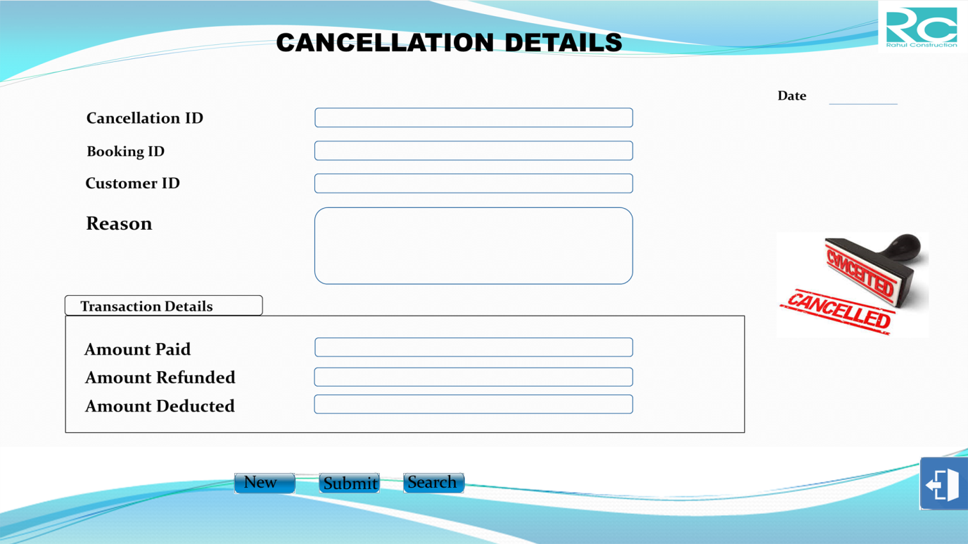

import java.awt.*;

import java.applet.*;

import java.io.*;

import java.sql.*;

import java.util.*;

public class payment extends JFrame implements ActionListener,FocusListener

{

JTextField txtPaymentID=new JTextField("");

JTextField txtDateOfPayment=new JTextField("");

JTextField txtPaymentType=new JTextField("");

JTextField txtBookingID=new JTextField("");

JTextField txtBookingType=new JTextField("");

JTextField txtCustomerID=new JTextField("");

JTextField txtCustomerName=new JTextField("");

JTextField txtAmountPaid=new JTextField("");

JTextField txtAmountDue=new JTextField("");

JTextField txtAmount=new JTextField("");

JTextField txtTotalAmount=new JTextField("");

JTextField txtChequeNo=new JTextField("");

JTextField txtAccountNo=new JTextField("");

JTextField txtChequeDate=new JTextField("");

JTextField txtBankName=new JTextField("");

JButton btnNew=new JButton("");

JButton btnPay=new JButton("");

JButton btnSearch=new JButton("");

JButton btnEdit=new JButton("");

JButton btnCancel=new JButton("");

JRadioButton rbcash=new JRadioButton("Cash");

JRadioButton rbcheque=new JRadioButton("Cheque");

ButtonGroup bg=new ButtonGroup();

public payment()

{

txtPaymentID.setBounds(493,162,432,35);

txtDateOfPayment.setBounds(1693,119,150,35);

txtPaymentType.setBounds(493,228,432,35);

txtBookingID.setBounds(493,299,431,35);

txtBookingType.setBounds(493,365,431,35);

txtCustomerID.setBounds(1387,204,432,35);

txtCustomerName.setBounds(1387,271,432,35);

txtAmount.setBounds(496,564,173,34);

txtChequeNo.setBounds(1032,541,173,35);

txtAccountNo.setBounds(1032,589,173,35);

txtChequeDate.setBounds(1032,637,173,35);

txtBankName.setBounds(1032,688,173,35);

txtTotalAmount.setBounds(495,752,173,34);

txtAmountPaid.setBounds(494,807,173,33);

txtAmountDue.setBounds(494,864,173,33);

rbcash.setBounds(493,495,110,35);

rbcheque.setBounds(640,495,110,35);

btnNew.setBounds(467,970,115,40);

btnPay.setBounds(620,970,117,40);

btnSearch.setBounds(780,970,117,40);

btnEdit.setBounds(937,973,117,40);

btnCancel.setBounds(1827,935,120,105);

add(txtPaymentID);

add(txtDateOfPayment);

add(txtPaymentType);

add(txtBookingID);

add(txtBookingType);

add(txtCustomerID);

add(txtCustomerName);

add(txtTotalAmount);

add(txtAmountPaid);

add(btnNew);

add(btnPay);

add(btnSearch);

add(btnEdit);

add(btnCancel);

btnNew.addActionListener(this);

btnPay.addActionListener(this);

btnSearch.addActionListener(this);

btnEdit.addActionListener(this);

btnCancel.addActionListener(this);

}

if(e.getSource()==btnNew)

{

try

{

txtPaymentID.setText("");

txtDateOfPayment.setText(sdate);

txtPaymentType.setText("");

txtBookingID.setText("");

txtBookingType.setText("");

txtTotalAmount.setText("");

txtAmountPaid.setText("");

txtAmountDue.setText("");

txtCustomerID.setText("");

txtCustomerName.setText("");

bg.clearSelection();

}

catch( Exception e1)

{

System.out.println(e1);

}

}

if(e.getSource()==btnPay)

{

try

{

Connection con=DriverManag.getConnection("jdbc:odbc:constructdsn");

String str="insert into paymenttbl(payment_ID,date_of_payment,

payment_type,booking_ID,booking_type,payment_mode,

amount,cheque_no,account_no,cheque_date,bank_name,customer_ID

,customer,total,amt_paid,amt_due)values(?,?,?,?,?,?,?,?,?,?,?,?,?,?)";

ps.setString(1,(txtPaymentID.getText()));

ps.setString(2,(txtDateOfPayment.getText()));

ps.setString(3,(txtPaymentType.getText()));

ps.setString(4,(txtBookingID.getText()));

ps.setString(5,(txtBookingType.getText()));

ps.setString(7,(txtAmount.getText()));

ps.setString(12,(txtCustomerID.getText()));

ps.setString(13,(txtCustomerName.getText()));

ps.setString(14,(txtTotalAmount.getText()));

ps.setString(15,(txtAmountPaid.getText()));

ps.setString(16,(txtAmountDue.getText()));

}

catch(Exception ee)

{

System.out.println(ee);

}

}

if(e.getSource()==btnSearch)

{

try

{

Connection con=Driver.getConnection("jdbc:odbc:constructdsn");

Statement st=con.createStatement();

String stt=JOptionPane.showInput(null,"Enter Payment ID");

String str="select * from paymenttbl where payment_ID='

"+txtPaymentID.getText()+"'";

while(res.next())

{

txtPaymentID.setText(stt);

txtDateOfPayment.setText(res.getString(2));

txtPaymentType.setText(res.getString(3));

txtBookingID.setText(res.getString(4));

txtBookingType.setText(res.getString(5));

if(res.getString(6).equals("Cash"))

rbcash.setSelected(true);

else

rbcheque.setSelected(true);

txtAmount.setText(res.getString(7));

txtChequeNo.setText(res.getString(8));

txtAccountNo.setText(res.getString(9));

txtChequeDate.setText(res.getString(10));

txtBankName.setText(res.getString(11));

txtCustomerID.setText(res.getString(12));

txtCustomerName.setText(res.getString(13));

txtTotalAmount.setText(res.getString(14));

txtAmountPaid.setText(res.getString(15));

txtAmountDue.setText(res.getString(16));

}

catch(Exception ce)

{

JOptionPane.showMessage(null,ce);

}

}

if(e.getSource()==btnEdit)

{

try

{

Connection con=Driver.getConnection("jdbc:odbc:constructdsn");

Statement st=con.createStatement();

String tt=JOptionPane.showInput(null,"Enter Cancellation ID");

String str="update paymenttbl set date_of_payment='

"+txtDOP.getText()+"',payment_type='"+txtPaymentType

gtText()+"',booking_ID='"+txtBookingID.getText()+"',booking_

type='"+txtBookingType.getText()+"',payment_mode',amount

='"+txtAmount.getText()+"',cheq_no='"+txtChequeNo.getText

()+"',Cheq_Date='"+txtChequeDate.getText()+"',bank_name='

"+txtBankNm.getText()+"',customer_ID='"+txtCustomerID+"'

,customer_name='"+txtCustomerName.getText()+"',total_amt

='"+txtTotalAmount.getText()+"',amt_paid='"+txtAmountPaid

.getText()+"txtamt”',amt_due='"' where payment_ID='"+tt+"'";

JOptionPane.showMessage(null,"RECORD UPDATED");

}

catch(Exception eee)

{

JOptionPane.showMessage(null,eee);

}

}

if(e.getSource()==btnCancel)

{

this.dispose();

}

}

public static void main(String args[])throws IOException

{

payment obj=new payment();

}

}

**13. DAILY REPORT FORM**

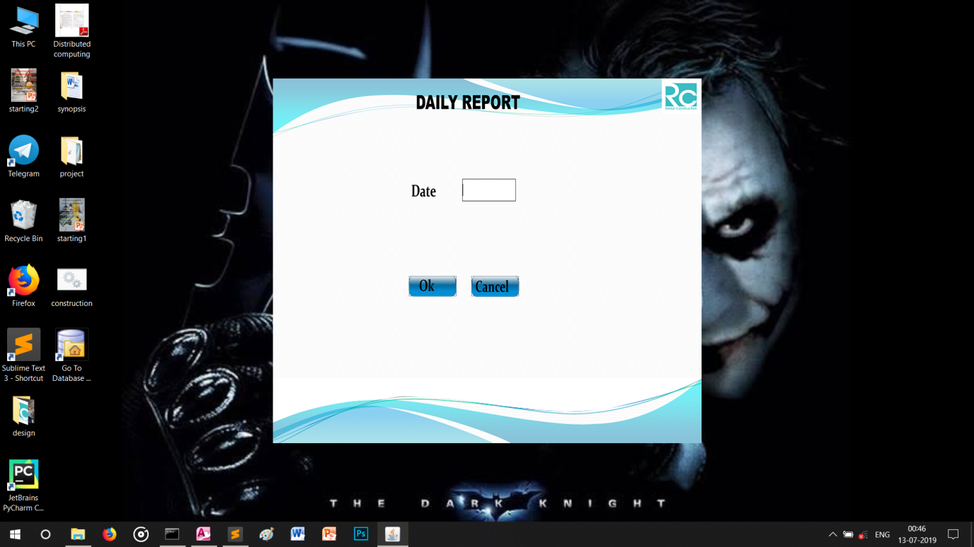

import java.awt.*;

import java.awt.event.*;

import java.applet.*;

import java.io.*;

import javax.swing.*;

import java.sql.*;

import java.util.*;

public class dailyreport extends JFrame implements ActionListener

{

JTextField txtDate=new JTextField();

JButton btnOk=new JButton("");

JButton btnCancel=new JButton("");

JLabel limg=new JLabel(new ImageIcon("E:/project/design/date.png"));

public datereport()

{

txtDate.setBounds(374,199,107,43);

btnOk.setBounds(268,390,94,40);

btnCancel.setBounds(391,390,94,40);

add(txtDate);

add(btnOk);

add(btnCancel);

btnOk.addActionListener(this);

btnCancel.addActionListener(this);

add(limg);

}

public void actionPerformed(ActionEvent e)

{

if(e.getSource()==btnOk)

{

int ctr=0;

try

{

Connection con=DriMnager.getConnection("jdbc:odbc:constructdsn");

Statement st=con.createStatement();

String sdate="select * from bookingtbl where

date_of_booking='"+txtDate.getText()+"'";

ResultSet res=st.executeQuery(sdate);

PrintWriter pw=new PrintWriter("report.txt");

pw.println("");

pw.println("");

pw.println("Rahul Township Pvt. Ltd.");

pw.println(" --------------------------");

pw.println("");

pw.println("");

pw.println("");

pw.println(" Booking ID Booking Type Flat No Duplex No

Price Customer ID Customer Name Contact No Address");

pw.println(" ------------------------------------------------------------------

----------------------------------------------------------------");

while(res.next())

{

ctr++;

String tsta=res.getString(1);

int len=tsta.length();

for(int i=1;i<19-len;i++)

{

pw.print(" ");

}

pw.print(tsta);

String tstb=res.getString(3);

int len1=tstb.length();

for(int ii=1;ii<18-len1;ii++)

{

pw.print(" ");

}

pw.print(tstb);

String tstc=res.getString(4);

int len3=tstc.length();

for(int i=1;i<13-len3;i++)

{

pw.print(" ");

}

pw.print(tstc);

String tstd=res.getString(5);

int len4=tstd.length();

for(int ii=1;ii<19-len4;ii++)

{

pw.print(" ");

}

pw.print(tstd);

String tstg=res.getString(8);

int len7=tstg.length();

for(int ii=1;ii<13-len7;ii++)

{

pw.print(" ");

}

pw.print(tstg);

String tsth=res.getString(9);

int len8=tsth.length();

for(int ii=1;ii<16-len8;ii++)

{

pw.print(" ");

}

pw.print(tsth);

String tsti=res.getString(10);

int len9=tsti.length();

for(int ii=1;ii<18-len9;ii++)

{

pw.print(" ");

}

pw.print(tsti);

String tstl=res.getString(13);

int len12=tstl.length();

for(int ii=1;ii<16-len12;ii++)

{

pw.print(" ");

}

pw.print(tstl);

String tstn=res.getString(15);

int len14=tstn.length();

for(int ii=1;ii<13-len14;ii++)

{

pw.print(" ");

}

pw.print(tstn);

pw.println();

pw.close();

}

}

catch(Exception ee)

{

System.out.print(e);

}

}

if(e.getSource()==btnCancel)

{

this.dispose();

}

}

public static void main(String args[])throws IOException

{

dailyreport obj=new datereport();

}

}

**14.MONTHLY REPORT FORM**

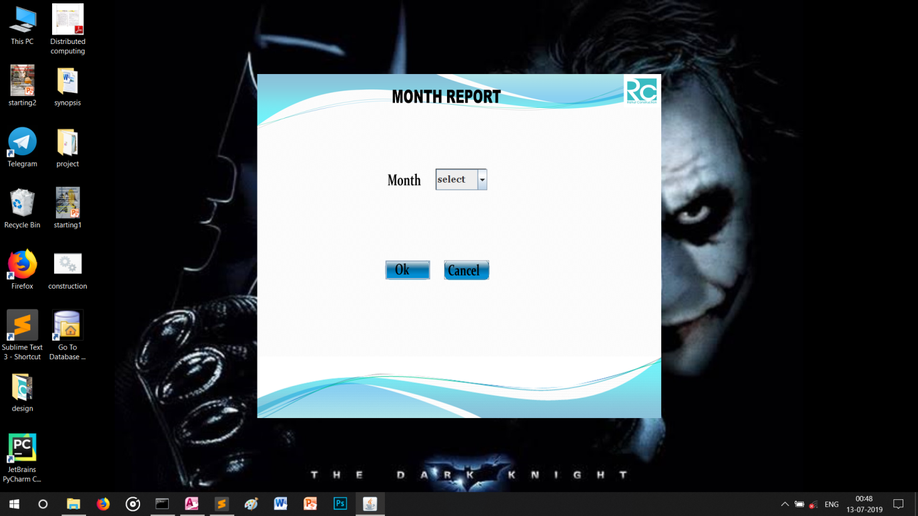

import java.awt.*;

import java.awt.event.*;

import java.applet.*;

import java.io.*;

import javax.swing.*;

import java.sql.*;

import java.util.*;

public class monthlyreport extends JFrame implements ActionListener

{

JButton btnOk=new JButton("");

JButton btnCancel=new JButton("");

JLabel limg=new JLabel(new ImageIcon("E:/project/design/month.png"));

String month[]={"select","January","February","March","April",”May”,”June”,

"July","August","September","October","November","December"};

JComboBox cmbMonthName=new JComboBox(bmonth);

public monthlyreport()

{

cmbMonthName.setFont(new Font("Georgia",Font.BOLD,20));

cmbMonthName.setBounds(374,199,107,44);

btnOk.setBounds(268,390,94,40);

btnCancel.setBounds(391,390,94,40);

add(cmbMonthName);

add(btnOk);

add(btnCancel);

btnOk.addActionListener(this);

btnCancel.addActionListener(this);

add(limg);

limg.setBounds(0,0,this.getWidth(),this.getHeight());

}

public void actionPerformed(ActionEvent e)

{

if(e.getSource()==btnOk)

{

try

{

Connection con=DriManager.getConnection("jdbc:odbc:constructdsn");

String sdate="select * from paymenttbl ";

Statement st=con.createStatement();

pw.println("Rahul Township Pvt. Ltd.");

pw.println(" --------------------------");

pw.println(" Payment ID Date of Payment Payment Type Booking

ID Booking Type Payment Mode Amount Customer ID Customer

Name");

while(res.next())

{

String mstr="";

mstr=res.getString(2);

int m1=Integer.parseInt(mmm[1]);

{

String tsta=res.getString(1);

int len=tsta.length();

for(int i=1;i<12-len;i++)

{

pw.print(" ");

}

String tste=res.getString(3);

int len3=tstc.length();

for(int i=1;i<18-len3;i++)

{

pw.print(" ");

}

pw.print(tstc);

String tstd=res.getString(4);

int len4=tstb.length();

for(int ii=1;ii<16 -len4;ii++)

{

pw.print(" ");

}

pw.print(tsta);

String tste=res.getString(5);

int len1=tste.length();

for(int i=1;i<18-len5;i++)

{

pw.print(" ");

}

pw.print(tste);

String tstf=res.getString(6);

int len6=tstf.length();

for(int ii=1;ii<15-len6;ii++)

{

pw.print(" ");

}

pw.print(tstf);

String tstg=res.getString(7);

int len7=tstg.length();

for(int ii=1;ii<14-len7;ii++)

{

pw.print(" ");

}

pw.print(tstg);

String tstf=res.getString(12);

int len81=tstf.length();

for(int ii=1;ii<16-len8;ii++)

{

pw.print(" ");

}

pw.print(tsth);

String tsti=res.getString(13);

int len9=tsti.length();

for(int ii=1;ii<18-len9;ii++)

{

pw.print(" ");

}

pw.print(tsti);

pw.println();

}

}

}

catch(Exception ee)

{

System.out.print(ee);

}

}

if(e.getSource()==btnCancel)

{

this.dispose();

}

}

public static void main(String args[])throws IOException

{

monthlyreport obj=new monthlyreport();

}

}

**15. AVAILABILITY REPORT FORM**

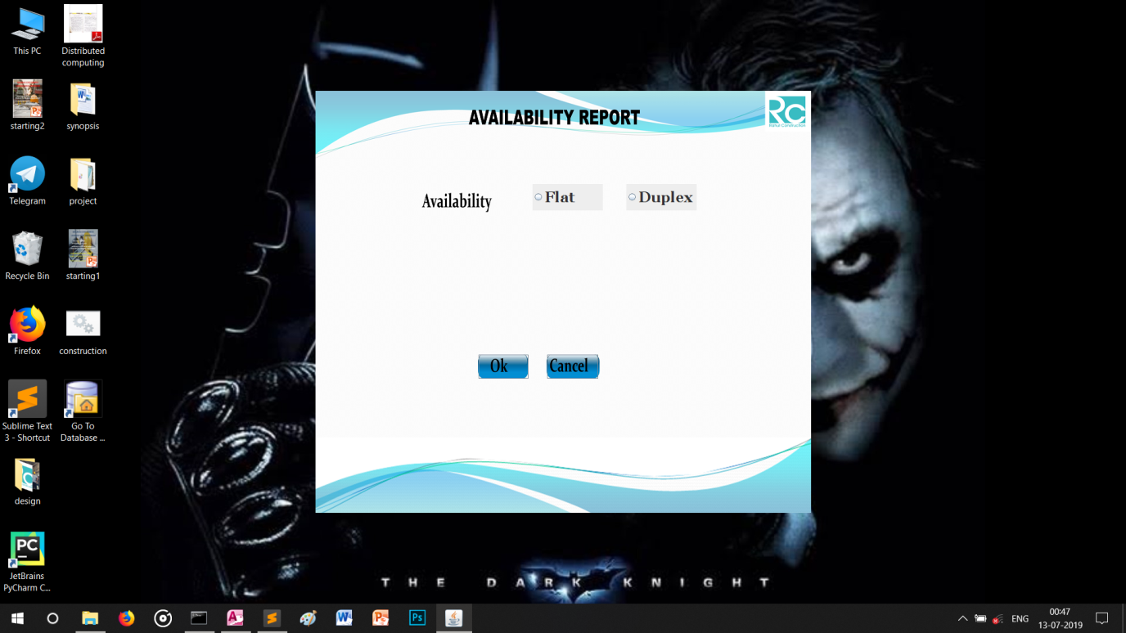

import java.awt.*;

import java.awt.event.*;

import java.applet.*;

import java.io.*;

import javax.swing.*;

import java.sql.*;

import java.util.*;

public class availablereport extends JFrame implements ActionListener

{

Button btnOk=new JButton("");

JButton btnCancel=new JButton("");

JRadioButton rbflat=new JRadioButton("Flat");

JRadioButton rbduplex=new JRadioButton("Duplex");

ButtonGroup bg=new ButtonGroup();

JLabel limg=new JLabel(new ImageIcon("E:/project/design/availability.png"));

public availablereport()

{

rbflat.setFont(new Font("Georgia",Font.BOLD,25));

rbduplex.setFont(new Font("Georgia",Font.BOLD,25));

rbflat.setBounds(370,159,120,45);

rbduplex.setBounds(530,159,120,45);

btnOk.setBounds(278,450,85,41);

btnCancel.setBounds(395,450,87,41);

add(rbflat);

add(rbduplex);

bg.add(rbflat);

bg.add(rbduplex);

add(btnOk);

add(btnCancel);

btnOk.addActionListener(this);

btnCancel.addActionListener(this);

rbduplex.addActionListener(this);

}

public void actionPerformed(ActionEvent e)

{

if(e.getSource()==btnOk)

{

if(rbflat.isSelected())

{

try

{

ConnectionDiverMana.getConnection("jdbc:odbc:constructdsn");

Statement st=con.createStatement();

String sdate="select * from flattbl where

flat_available='Available'";

ResultSet res=st.executeQuery(sdate);

pw.println("Rahul Township Pvt. Ltd.");

pw.println(" --------------------------");

pw.println(" Flat No Flat Floor Flat Building

Builtup Area Maintainance Price");

pw.println(" ----------------------------------------------------------“)

while(res.next())

{

String tsta=res.getString(1);

int len=tsta.length();

for(int i=1;i<15-len;i++)

{

pw.print(" ");

}

String tstb=res.getString(2);

int len1=tstb.length();

for(int ii=1;ii<20-len1;ii++)

{

pw.print(" ");

}

String tstc=res.getString(3);

int len3=tstc.length();

for(int i=1;i<25-len3;i++)

{

pw.print(" ");

}

String tstd=res.getString(4);

int len4=tstd.length();

for(int ii=1;ii<25 -len4;ii++)

{

pw.print(" ");

}

String tste=res.getString(5);

int len5=tste.length();

for(int i=1;i<23-len5;i++)

{

pw.print(" ");

}

String tstf=res.getString(6);

int len6=tstf.length();

for(int ii=1;ii<17-len6;ii++)

{

pw.print(" ");

}

pw.println();

}

}

catch(Exception eee)

{

System.out.print(eee);

}

}

else

{

if(rbduplex.isSelected())

{

try

{

Connection con=DrverMar.getConnection("jdbc:odbc:constructdsn");

Statement st=con.createStatement();

String sdate="select * from duplextbl “;

pwr.println("Rahul Township Pvt. Ltd.");

pwr.println(-------------------------------");

pwr.println(" Duplex No Flat Building Builtup Area

Maintainance Price");

pwr.println(" ------------------------------------------------------------");

while(res1.next())

{

String tstaa=res1.getString(1);

int len7=tstaa.length();

for(int i=1;i<16-len7;i++)

{

pwr.print(" ");

}

String tstbb=res1.getString(2);

int len8=tstbb.length();

for(int ii=1;ii<25-len8;ii++)

{

pwr.print(" ");

}

String tstcc=res1.getString(3);

int len9=tstcc.length();

for(int i=1;i<25-len9;i++)

{

pwr.print(" ");

}

String tstdd=res1.getString(4);

int lenn=tstdd.length();

for(int ii=1;ii<23-lenn;ii++)

{

pwr.print(" ");

}

String tstee=res1.getString(5);

int lenn1=tstee.length();

for(int i=1;i<17-lenn1;i++)

{

pwr.print(" ");

}

pwr.println();

}

}

catch(Exception ee)

{

System.out.print(ee);

}

}

if(e.getSource()==btnCancel)

{

this.dispose();

}

}

public static void main(String args[])throws IOException

{

availablereport obj=new availablereport();

}

}

**Future improvement**

Every Edition of an book comes with new topics and modifications if any errors are present. In the similar way, in near future, our application will overcome the flaws if occurred, and attains new features offered to employees for the Flexible and easy Transportation.

Following are the Enhancements to the application:

• Provide good user interface.

• Enhances relationship between customers and management agencies.

• Provide access permission to the employees

• Add new flat to represent in the flat list.

• Optimises the performance level.

• The User payment for the current receipt of the payment.

• Add the current project for booking easy.

• Messages can be delivered to respective e mail inbox of a particular customer informing him/her about his/her completion of registration along with “user name and password”.

• Now both your construction management business and website can run smoothly, by accepting reservation and managing entire fleet , all from one single control panel. By offering highly customizable booking system and software, customers can see exact availability.

• It eases the hiring and selling process and all construction management services.

Conclusion

Our project is a humble venture to satisfy the needs in an institution. The system is developed with much care that is free from errors and at the same time, it is efficient and less time consuming. Our aim is to provide a very user friendly customer registration system who want to book flat , duplex or both. In this application only one person has been given access rights and it is restricted up to the functionalities, so that the data is maintained securely and redundant data is prevented .

Several user-friendly coding are adopted. The important thing is that the system is robust. Avoid malfunctioning from outsiders. It goes through all phases of software development cycle. So, product is accurate. Also provision is provided for future development in the system.

A special thanks to our mentor for the guidance and blessing which was provided for the completion of our project. We welcome your co operation and feedback.

BIBLOGRAPHY

The main aim of developing CAR RENTAL SYSTEM is to provide all information that is required by the customers. User friendliness is a must that is the user must get the details without complicated searching procedures. Other important requirements of software are data security, extensibility and maintainability. All these features are included in this web application. The project greatly helped in understanding the various phases in website development and exposure to a new developer platform JAVA and SQL.

**REFRENCE:**

BOOKS-

• “SQL,PL/SQL,The Programming Language Of Oracle”-Ivan Bayross

• “Data System Concept”-Abraham Silverschatz, Henry K. Forth and D. b

Sudarshan

WEBSITES-

* www.slideshare.com
* www.scribd.com
* www.wikipidiea.com
* www.code-project.com

Developed by Rahul kumar chaudhary